Media Release

Monday 9th December 2019
Yarram Pump Station Upgrade
Construction crews are packing down at Yarram’s Lawler Street pump station upgrade project. Works have been ongoing for the latter half of 2019 to construct a new sewer pump station for Yarram, which will provide more capacity and extra storage to deal with storm events. It is a key project as part of South Gippsland Water’s commitment to safe, reliable wastewater services.

People in the area may have seen works at the site in Lawler Street. To date the construction crew have:
- Escavated a 15 meter pump well and lined this via the ring and timbers method
- Installed components of the packaged pump station including the pump station well, flow meter pit and valve pit
- Demolished one building on the site, with another to be taken down in 2020

Crews will be back on site in the new year to complete all site electrics and controls, install the new larger pump and convert the existing pump station to an expanded emergency storage. 2020 will also see the brand new bigger pumps put into service.

Thank you to the customers and community in the vacinity of these works, for their paitence whist our crews complete this important upgarde to Yarram’s sewer system.

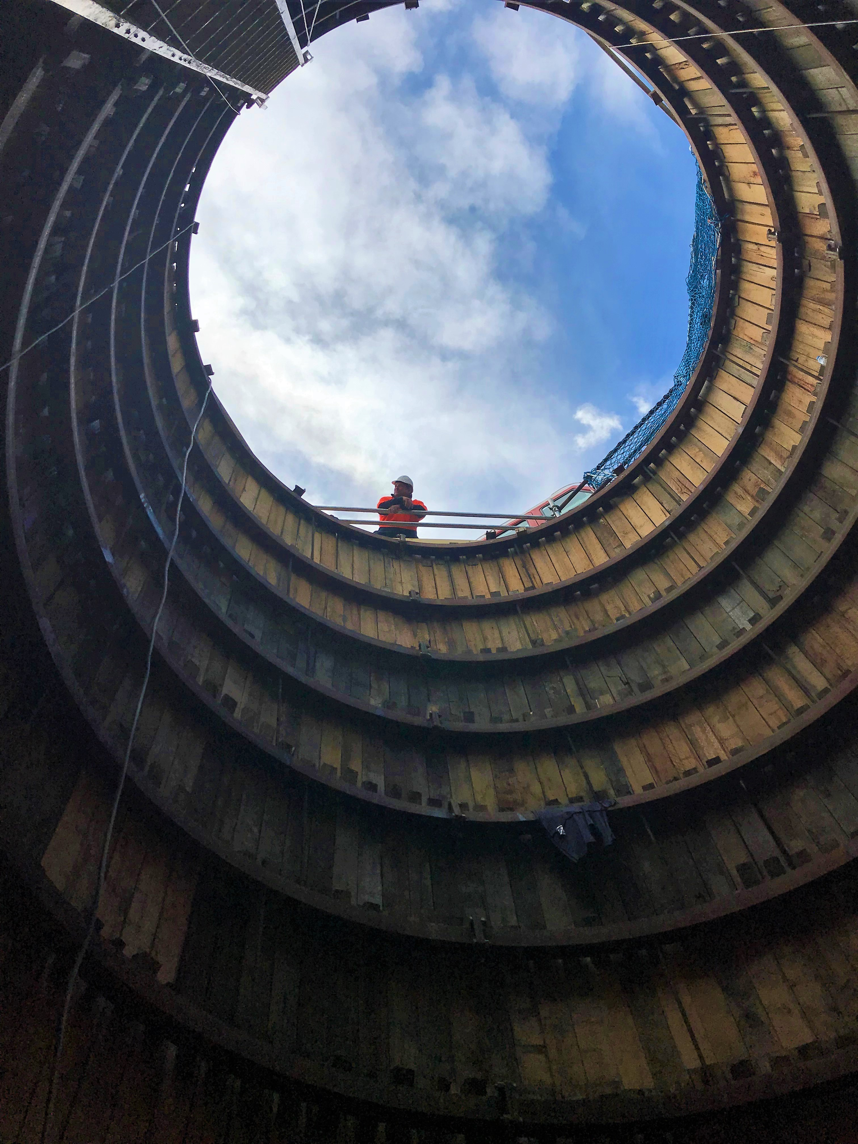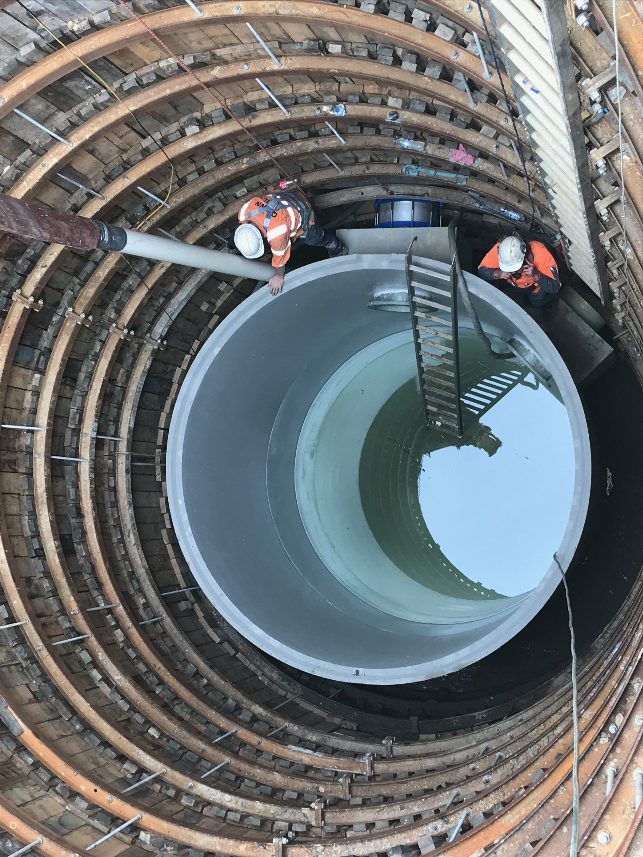

Images: The pump well excavation and installation.

[ENDS]

