WATER SECURITY OUTLOOK
NOVEMBER 2025
Water Supply Information
Water resources held by South Gippsland Water for the Foster Water Supply System are shown below. Only 13% of the available annual entitlement has been used from Deep Creek Reservoir in the current year to date (Jul-Sep 2025). This entitlement is a legal right to access water, subject to availability.
Water Component | Maximum Annual  Entitlement | Volume Extracted 2025-26 | Volume Remaining 2025-26
Deep Creek Reservoir | 326 ML | 42 ML | 284 ML

Water Consumption
Monthly water consumption for the Foster Water Supply System in the year to date has been mostly lower than the average recorded demand over the last five years. It is expected that demand will be close to the historical average for the remainder of the year.

Foster Water Supply System

The town of Foster receives its water supply from a 6 ML weir on Deep Creek. Water harvested from the creek can be transferred to Foster Dam, which has a capacity of 233 ML and a raw water basin of 24 ML capacity. The supply system storage allows water harvested in a wet year to be stored and then supplied to customers in a dry year.

South Gippsland Water
1300 851 636
www.sgwater.com.au
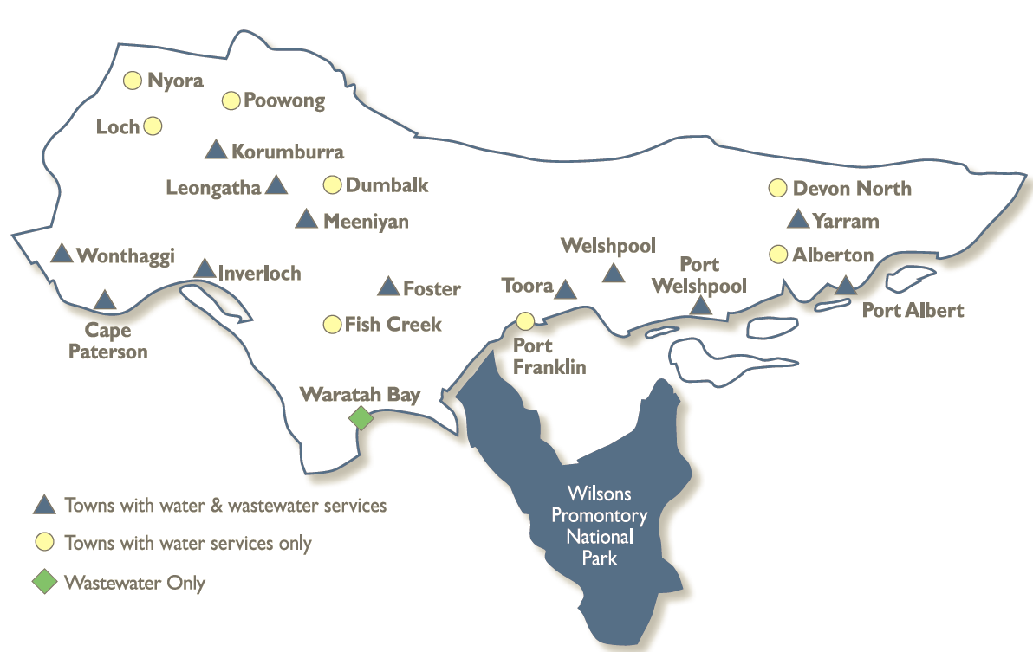
WATER SECURITY OUTLOOK
NOVEMBER 2025

Climate Conditions
Forecast climate conditions for the coming three months have considered the Bureau of Meteorology’s seasonal climate forecast for the region and local climate conditions in the year to date. Winter/spring rainfall in the year to date has been less than the long-term average, and the Bureau’s climate outlook indicates an even chance of wetter or drier than usual conditions over the next three months. Air temperature is forecast over the next three months to be warmer than usual for this time of year, and this trend is expected to continue beyond this period. After taking these factors into account, South Gippsland Water is forecasting on the basis of an average climate scenario
Chance of Exceeding Median Rainfall | Chance of Exceeding Median Maximum Temperature | This Year’s Winter/Spring Rainfall | Likely Outlook Scenario
50-55% | Greater than 80% | Below Average | Average

Further Information:
- The weir on Deep Creek was 100% full and Foster Dam was 86% full at the end of October. The raw water basin was also 100% full.
- Volumes shown in the storage outlook are start of month values in megalitres (ML), where 1 ML is equivalent to 1 million litres.

Urban Water Restrictions Outlook
The volume in storage outlook for the Foster Water Supply System for the period November 2025 to October 2026 indicates that storage levels are expected to remain high relative to water restriction triggers over the coming year.

Based on the volume in storage outlook and the Bureau of Meteorology climate forecast, no water restrictions are anticipated for the remainder of the year at the current time. South Gippsland Water’s Permanent Water Saving Rules applies to all customers over the outlook period.
Climate Scenario | Outlook
Climate Scenario | 1 Jan 2026 | 1 Apr 2026 | 1 Jul 2026
Wet | PWSR | PWSR | PWSR
Average | PWSR | PWSR | PWSR
Dry | PWSR | PWSR | PWSR
Worst on Record | PWSR | PWSR | PWSR
PWSR Permanent Water Savings Rules

South Gippsland Water
1300 851 636
www.sgwater.com.au

WATER SECURITY OUTLOOK
NOVEMBER 2025

Action Plan
A list of priority actions for this supply system prior to the next update of the Urban Water Strategy in 2027 is presented below. Further information on actions can be found in our 2022 Urban Water Strategy and our Price Submission 2023-2028 publication on our website. Victoria’s permanent water savings rules are always in place in South Gippsland, saving water on an ongoing basis. For additional tips about how to save water see our smart water advice.
Action Name | Timing
Water awareness and efficiency programs | Ongoing
Leak reduction | Ongoing
Reuse opportunities | Ongoing
Update water security outlook | Every November
Planning for long term options as per the Urban Water Strategy | 2022-2027

The information provided in this water security outlook is intended as a guide only. An update will be issued if conditions change during the outlook period.

South Gippsland Water
1300 851 636
www.sgwater.com.au
Blah

Water Consumption
Lance Creek Water Supply System monthly actual water consumption versus historical consumption

Table

Water Supply Information
Water resources held by South Gippsland Water for the Lance Creek Water Supply System

