WATER SECURITY OUTLOOK
NOVEMBER 2025
South Gippsland Water
1300 851 636
www.sgwater.com.au
Lance Creek Water Supply System supplies water to the townships of:
- Wonthaggi
- Cape Paterson
- Inverloch
- Korumburra
- Poowong
- Loch
- Nyora
The Lance Creek Supply System includes the following water sources:
- Lance Creek Reservoir: 4,200ML capacity
- Greater Yarra System – Thomson River Pool: 1,000 ML entitlement plus any unused water carried over from previous years plus trade
Water Supply Information
Water resources held by South Gippsland Water for the Lance Creek Water Supply System are shown below. In the year to date (Jul-Sep 2025), 320 ML of the available annual entitlement from Lance Creek Reservoir has been used. This entitlement is a legal right to access water, subject to availability.

A significant supply volume is also available to the Lance Creek Water Supply System from the Greater Yarra System – Thomson River Pool (Melbourne Water Supply System). South Gippsland Water has been allocated 23.9% of its entitlement from the Melbourne Water Supply System in the year to date. Based on projections by Melbourne Water, this year’s allocation is expected to increase over the coming months, even under the forecast average dry conditions (see overleaf) over the outlook period. South Gippsland Water has also carried over 858 ML of unused allocations from previous years to the current year, providing a significant supply buffer in this supply system if conditions were to become drier than expected.

Water Component | Maximum Annual  Entitlement | Year To Date Allocation | Carryover from Last Year* | Allocation Plus Carryover | Volume Extracted 2025-26 | Volume Remaining 2025-26
Lance Creek Reservoir | 3,800 ML | N/a | N/a | N/a | 320 ML | 3,480 ML
Melbourne Water Supply System | 1,000 ML | 239 ML | 858 ML | 1,097 ML | 729 ML | 367 ML
*After deductions for reservoir spills in the Melbourne Water Supply System

Lance Creek Water Supply System

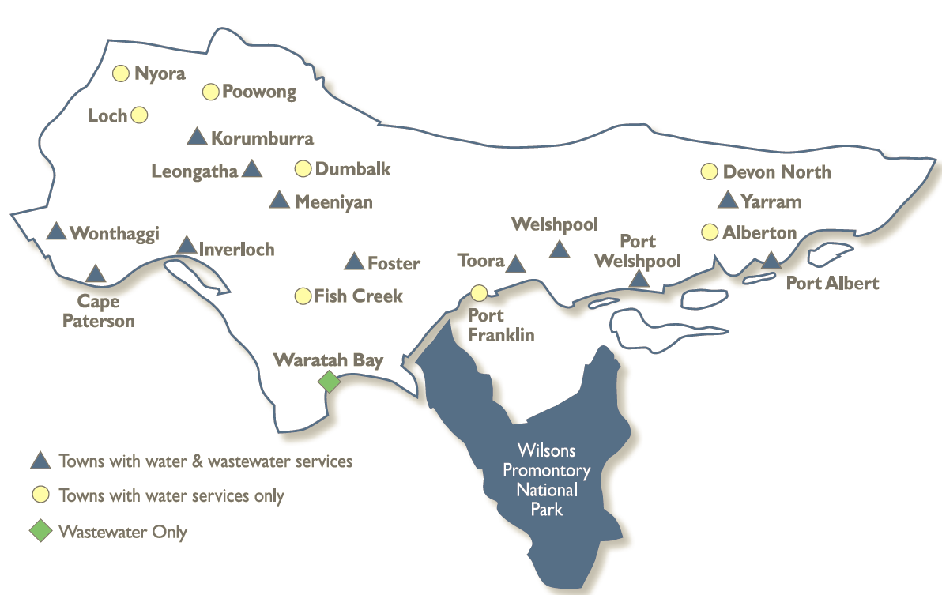
WATER SECURITY OUTLOOK
NOVEMBER 2025

Water Consumption
Water consumption for the Lance Creek Water Supply System in the year to date has been above the average demand over the last five years. Water restriction triggers were revised in 2025 with this in consideration, in response to drier conditions during the year. The higher year to date demand is partly due to increased major industrial water use. It is expected that the demand will be closer to the historical average for the remainder of the year. Demand in this supply system typically increases in summer due to both the warmer weather and visitors to the Bass Coast, particularly at Inverloch and Cape Paterson.

Climate Conditions
Forecast climate conditions for the coming three months have considered the Bureau of Meteorology’s seasonal climate forecast for the region and local climate conditions in the year to date. Winter/spring rainfall in the year to date has been less than the long-term average, and the Bureau’s climate outlook indicates an even chance of wetter or drier than usual conditions over the next three months. Air temperature is forecast over the next three months to be warmer than usual for this time of year, and this trend is expected to continue beyond this period. After taking these factors into account, South Gippsland Water is forecasting on the basis of an average climate scenario.
Chance of Exceeding Median Rainfall | Chance of Exceeding Median Maximum Temperature | This Year’s Winter/Spring Rainfall | Likely Outlook Scenario
50-55% | Greater than 80% | Less than average | Average

South Gippsland Water
1300 851 636
www.sgwater.com.au

WATER SECURITY OUTLOOK
NOVEMBER 2025

Further Information:
- Lance Creek Reservoir was 63% full at the end of October.

Urban Water Restrictions Outlook
The volume in storage outlook for Lance Creek Reservoir for the period November 2025 to October 2026 indicates that storage levels are expected to remain high relative to water restriction triggers over the coming year.

Based on the volume in storage outlook and the Bureau of Meteorology climate forecast, no water restrictions are anticipated for the remainder of the year at the current time. South Gippsland Water’s Permanent Water Saving Rules applies to all customers over the outlook period.
Climate Scenario | Outlook
Climate Scenario | 1 Jan 2026 | 1 Apr 2026 | 1 Jul 2026
Wet | PWSR | PWSR | PWSR
Average | PWSR | PWSR | PWSR
Dry | PWSR | PWSR | PWSR
Worst on Record | PWSR | PWSR | PWSR
PWSR Permanent Water Savings Rules

Action Plan
A list of priority actions for this supply system prior to the next update of the Urban Water Strategy in 2027 is presented below. Further information on actions can be found in our 2022 Urban Water Strategy and our Price Submission 2023-2028 publication on our website. Victoria’s permanent water savings rules are always in place in South Gippsland, saving water on an ongoing basis. For additional tips about how to save water see our smart water advice.
Action Name | Timing
Water awareness and efficiency programs | Ongoing
Leak reduction | Ongoing
Reuse opportunities | Ongoing
Access to additional water trade from the Melbourne Water Supply System | July 2026
Update water security outlook | Every November

The information provided in this water security outlook is intended as a guide only. An update will be issued if conditions change during the outlook period.

South Gippsland Water
1300 851 636
www.sgwater.com.au
Blah

Water Consumption
Lance Creek Water Supply System monthly actual water consumption versus historical consumption

Table

Water Supply Information
Water resources held by South Gippsland Water for the Lance Creek Water Supply System

