WATER SECURITY OUTLOOK
NOVEMBER 2025
Water Consumption
Monthly water consumption for the Leongatha Water Supply System in the year to date has been below the average demand over the last five years. This is primarily due to water use by major customers being 25% lower over the year to date, relative to the last 5 years.
Water Supply Information
Water resources held by South Gippsland Water for the Leongatha Water Supply System are shown below. Only 13% of the available annual entitlement from the Leongatha storages has been used in the current year to date (Jul-Sep 2025). This entitlement is a legal right to access water, subject to availability. No water has been diverted to the Leongatha storages from the local groundwater bore. Note that from February 2026, supplementary supply to Leongatha is planned to be made available temporarily from the former Korumburra storages, if needed.
Water Component | Maximum Annual  Entitlement | Volume Extracted 2025-26 | Volume Remaining 2025-26
No.1, No. 2, Hyland and Western Reservoirs | 2,476 ML | 328 ML | 2,148 ML

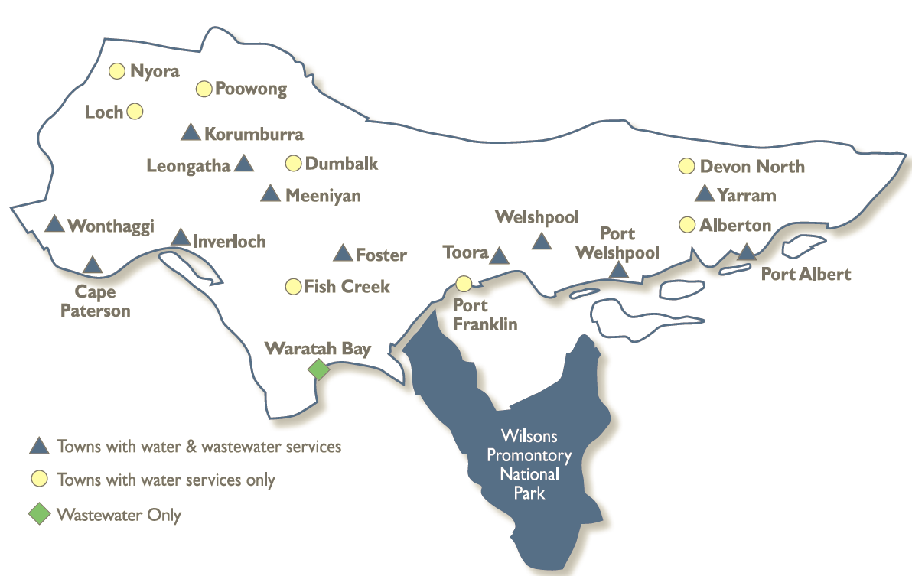
The town of Leongatha receives its primary water supply from four storages on Ruby Creek:
- Western Reservoir: 1,137 ML capacity
- Hyland Reservoir: 671 ML capacity
- No.2 Reservoir: 84 ML capacity
- No. 1 Reservoir: 15 ML capacity
Alternative supply during drought is also available from local groundwater bores.
Leongatha Water Supply System

South Gippsland Water
1300 851 636
www.sgwater.com.au
WATER SECURITY OUTLOOK
NOVEMBER 2025

Climate Conditions
Forecast climate conditions for the coming three months have considered the Bureau of Meteorology’s seasonal climate forecast for the region and local climate conditions in the year to date. Winter/spring rainfall in the year to date has been less than the long-term average, and the Bureau’s climate outlook indicates an even chance of wetter or drier than usual conditions over the next three months. Air temperature is forecast over the next three months to be warmer than usual for this time of year, and this trend is expected to continue beyond this period. After taking these factors into account, South Gippsland Water is forecasting on the basis of an average climate scenario.
Chance of Exceeding Median Rainfall | Chance of Exceeding Median Maximum Temperature | This Year’s Winter/Spring Rainfall | Likely Outlook Scenario
50-55% | Greater than 80% | Below Average | Average

Further Information:
- Total system storage for Leongatha was 77% of full capacity at the 15th of November
- Volumes shown in the storage outlook are start of month values in megalitres (ML), where 1 ML is equivalent to 1 million litres

Urban Water Restrictions Outlook
The volume in storage outlook for the Leongatha Water Supply System for the period November 2025 to October 2026 indicates that storage levels will remain above water restriction triggers over the coming year. Dry conditions in early 2025 had depleted reservoir levels such that restrictions during 2026 were starting to appear likely within the past 1-3 months. However, reservoir volumes have bounced back strongly following strong November rainfall, such that restrictions are no longer expected. The storage outlook includes supplementary supply from the Coalition Creek storages from February 2026. Connection to Korumburra’s dams will increase Leongatha’s harvestable catchment area from 9km² to 13km² for upcoming years.
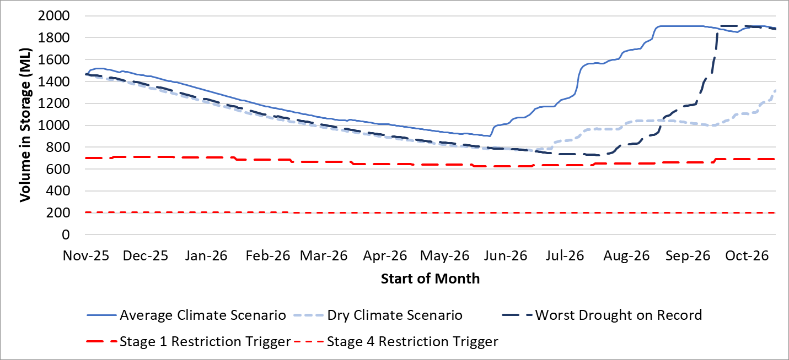

Based on the volume in storage outlook and the Bureau of Meteorology climate forecast, no water restrictions are anticipated for the remainder of the year at the current time. South Gippsland Water’s Permanent Water Saving Rules applies to all customers over the outlook period.
Climate Scenario | Outlook
Climate Scenario | 1 Jan 2026 | 1 Apr 2026 | 1 Jul 2026
Wet | PWSR | PWSR | PWSR
Average | PWSR | PWSR | PWSR
Dry | PWSR | PWSR | PWSR
Worst on Record | PWSR | PWSR | PWSR
PWSR Permanent Water Savings Rules

South Gippsland Water
1300 851 636
www.sgwater.com.au

WATER SECURITY OUTLOOK
NOVEMBER 2025

Action Plan
A list of priority actions for this supply system prior to the next update of the Urban Water Strategy in 2027 is presented below. The Urban Water Strategy identified that the Leongatha system is not able to meet South Gippsland Water’s long-term target service criteria for restrictions, and water restrictions can be expected on average once every 3-5 years (depending on climate change assumptions). Supplementary sources of water are available and ready to use if needed.
Further information on actions can be found in our 2022 Urban Water Strategy and our Price Submission 2023-2028 publication on our website. Actions at Leongatha include investigating expanded use of groundwater, the interconnection of disused reservoirs, and a connection to the Lance Creek System to improve reliability of supply at Leongatha. Since completing the Urban Water Strategy, South Gippsland Water has undertaken further investigations into each of these options, to identify and implement a preferred option.
Action Name | Timing
Water awareness and efficiency programs | Ongoing
Leak reduction | Ongoing
Reuse opportunities | Ongoing
Update water security outlook | Every November
Temporary connection from Korrumburra storages to Leongatha | February 2026
Seek State Government approval for permanent connection from Lance Creek System to Leongatha | 2026
Planning for long term options as per the Urban Water Strategy | 2022-2027
Review infrastructure to continue use of groundwater bores | Completed

Victoria’s permanent water savings rules are always in place in South Gippsland, saving water on an ongoing basis. For additional tips about how to save water see our smart water advice.
The information provided in this water security outlook is intended as a guide only. An update will be issued if conditions change during the outlook period.

South Gippsland Water
1300 851 636
www.sgwater.com.au
Blah

Water Consumption
Lance Creek Water Supply System monthly actual water consumption versus historical consumption

Table

Water Supply Information
Water resources held by South Gippsland Water for the Lance Creek Water Supply System

