

2025 Water Security Outlooks
Annual Water Outlook

28/11/2025

Document status
Client | South Gippsland Water
Project | 2025 Water Security Outlooks
Report title | Annual Water Outlook
Version | Final
Authors | Prepared by HARC and SGW
Project manager | Katherine Szabo (HARC), Andrew Hawes (SGW)
File name | SGW_2025Outlook_Final
Project number | 2025 Water Security Outlooks

Document history
Version | Date issued | Reviewed by | Approved by | Sent to | Comment
Draft A | 24/10/2025 | B.Neal (HARC) | B.Neal (HARC) | A.Hawes (SGW)
Draft B | 3/11/2025 | A Hawes, P Gana (SGW) | A Hawes (SGW) | J Quinn, T Spargo (DEECA)
Final A | 28/11/2025 | A Hawes (SGW) | A Hawes (SGW) | J Quinn, T Spargo (DEECA)

Copyright and Limitation
This report has been produced by Hydrology and Risk Consulting Pty Ltd ACN 603 391 993 (“HARC”) for South Gippsland Water . Unless otherwise indicated, the concepts, techniques, methods and information contained within the report are the intellectual property of HARC and may not be reproduced or used in any form by third parties without the express written consent of HARC and South Gippsland Water .
The report has been prepared based on the information and specifications provided to HARC by South Gippsland Water . HARC does not warrant this document as being complete, current or free from error and disclaims all liability for any loss, damage, costs or expenses (including consequential losses) relating from this report. It should only be used for its intended purpose by South Gippsland Water and should not be relied upon by third parties.
Copyright © Hydrology and Risk Consulting Pty Ltd ACN 603 391 993. All rights reserved.

Executive Summary
South Gippsland Water (SGW) currently manages eight water supply systems that provide water to 22 individual towns and locations. This document describes the expected outlook for these systems over the coming summer season, with the likelihood of restrictions in each system summarised in Table 1. In most instances, the forecasts below reflect the 12-month period from the start of November 2025 to the end of October 2026. The forecast period for run-of-river systems is 3 months from the start of November 2025 to the end of January 2026, reflecting the period over which the forecast has an acceptable level of uncertainty.
South Gippsland Water’s supply systems have remained resilient over the last 12 months, despite rainfall being the lowest on record (for the last 12 months to the end of September 2025) across most the region. Whilst an average climate outlook is anticipated over the coming months, SGW is preparing to bolster supplies where water restrictions are forecast likely to occur, in order to reduce the likelihood of more severe restrictions being needed. Under the forecast average climate conditions across the region, the following general statements can be made about the SGW systems over the outlook period:
- Restrictions are not considered likely or certain for all supply systems. There had been concern in recent months that Leongatha would be a likely risk of restrictions in 2026, however well above average November rainfall has significantly improved storage levels, such that restrictions for Leongatha are now considered unlikely.
- For Fish Creek, restrictions are not expected under the anticipated average climate scenario but could still be possible in late summer and autumn if conditions were to become drier than anticipated. Fish Creek (Battery Creek Storage) is a small system and can change quickly, both in response to rainfall, and in the event of sustained dry conditions for only a few months.
- For Toora, the likelihood of restrictions is assessed as rare, with restrictions projected to only occur if conditions were to become drier than indicated by the Bureau of Meteorology’s climate forecast and recent climate conditions. Toora is a run of river system with an on-stream supplementary storage capable of maintaining demand during shortfalls, most recently utilised in 2007.
- The systems with low storage capacity relative to demands (Dumbalk, Meeniyan and Yarram) have been assigned a restriction likelihood of very rare, as the recent streamflow conditions, as well as the forecast climate conditions, suggest streamflows will remain near or above average, well above South Gippsland Water’s restriction triggers. SGW will continue to monitor forecast climate conditions throughout summer and revise outlooks by March if below average conditions are forecast into autumn.
Additional supply risks for South Gippsland Water’s supply systems include water quality risks (blue-green algae risk) in Lance Creek Reservoir. This potential risk is managed at Lance Creek Reservoir through the use of seasonal supply from the Greater Yarra System – Thomson River Pool (Melbourne Water Supply System). Algaecides (Earthtec) are used when necessary, in order to treat and limit the extent of blue-green algae blooms within Lance Creek Reservoir and pose no risk to human health. Additionally, there is also a minor blue-green algae risk in the reservoirs supplying Leongatha and Foster. Extreme events or emergencies such as bushfires in our catchments, major loss of power supply or water contamination could require the implementation of restrictions to manage water demands. Bushfire risks are low across most of South Gippsland Water’s supply catchments due to low vegetation cover (less than ~30%) in these catchments, except for the catchments supplying Yarram, Toora and Foster.

Table 1 Outlook Summary
Supply Sources | Towns Supplied | Outlook Period | Likelihood of Restrictions⁽¹⁾
Ruby Creek Reservoirs | Leongatha, Koonwarra | 1 Nov 2025 to 31 Oct 2026 (12 months) | Unlikely
Lance Creek Reservoir and the Melbourne Water Supply System | Wonthaggi, Cape Paterson, Inverloch, Korumburra, Poowong, Loch, Nyora | 1 Nov 2025 to 31 Oct 2026 (12 months) | Very Rare
Tarwin River East Branch | Dumbalk | 1 Nov 2025 to 31 Jan 2026 (3 months) | Very Rare (to end of Jan 2026)
Tarwin River | Meeniyan | 1 Nov 2025 to 31 Jan 2026 (3 months) | Very Rare (to end of Jan 2026)
Deep Creek Reservoir and Foster Dam | Foster | 1 Nov 2025 to 31 Oct 2026 (12 months) | Very Rare
Battery Creek Reservoir | Fish Creek | 1 Nov 2025 to 31 Oct 2026 (12 months) | Possible
Cook’s Dam (Agnes River) | Toora, Welshpool, Port Welshpool, Port Franklin, Barry Beach | 1 Nov 2025 to 31 Oct 2026 (12 months) | Rare
Tarra River and groundwater | Yarram, Alberton, Port Albert, Devon North | 1 Nov 2025 to 31 Jan 2026 (3 months) | Very Rare (to end of Jan 2026)
⁽¹⁾ Explanation of the likelihood classification is available in Table 8

Contents
1. Introduction 1
1.1 Climate Summary 4
1.1.1 Victoria’s climate and streamflow in the longer-term context 4
1.1.2 Recent Climatic Conditions in South Gippsland 5
1.1.3 Recent Streamflow Conditions in South Gippsland 8
2. Current Water Resource Position 9
3. Climate Outlook 22
4. Forward Outlook 25
5. Short Term Action Plan 33

Introduction
South Gippsland Water (SGW) currently manages eight water supply systems that provide water to 22 individual towns and locations, listed in Table 1. A locality map of the towns supplied by SGW is shown in Figure 2.
Current raw water demand is presented in Table 2 to indicate the relative size of each supply system. Average residential customer demand for the entirety of South Gippsland is shown in Figure 1.
Table 2 Water Supply Systems managed by SGW
Supply System | Towns Supplied | Number of Connections | Current average raw water demand (ML/year) ⁽¹⁾
Lance Creek | Wonthaggi, Cape Paterson, Inverloch | 14,404 | 1,630
Lance Creek | Poowong, Loch, Nyora | 14,404 | 280
Lance Creek | Korumburra | 14,404 | 790
Ruby Creek | Leongatha, Koonwarra | 3,436 | 1,670
Tarwin River | Meeniyan | 278 | 51
Tarwin River East Branch | Dumbalk | 109 | 17
Battery Creek | Fish Creek | 209 | 110
Deep Creek/Foster Dam | Foster | 953 | 170
Agnes River | Toora, Welshpool, Port Welshpool, Port Franklin, Barry Beach Port | 1,133 | 520
Tarra River | Yarram, Alberton, Port Albert, Devon North | 1,883 | 440
TOTAL |  |  | 5,700
⁽¹⁾ Taken from the SGW’s Urban Water Strategy (2022), average annual raw water demand estimated at current level of population and industrial development over a long-term climate sequence (50 years) to account for differences in water demand in wet, average and dry years.

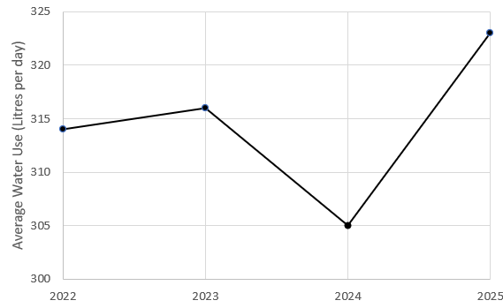
Figure 1 Average daily residential customer demand in each year

SGW prepared an update to its Urban Water Strategy (UWS) in 2022. This document, published on SGW’s website, outlines SGW’s long term plan to balance the supply of water to meet the region’s residential, business, industry and community water needs. The UWS identifies systems where future water supplies may need to be enhanced in order to meet the growing demands and be resilient to climate change. The UWS is complemented by a Drought Preparedness Plan (DPP) which provides SGW with a ready reference for operational guidance in times of drought. The DPP details the actions SGW will take in order to prepare for and to respond to periods of water scarcity. This Water Security Outlook is one such action.
The 2022 UWS includes 60 actions, of which SGW has completed 9 to date. A further 36 of these actions are currently underway.

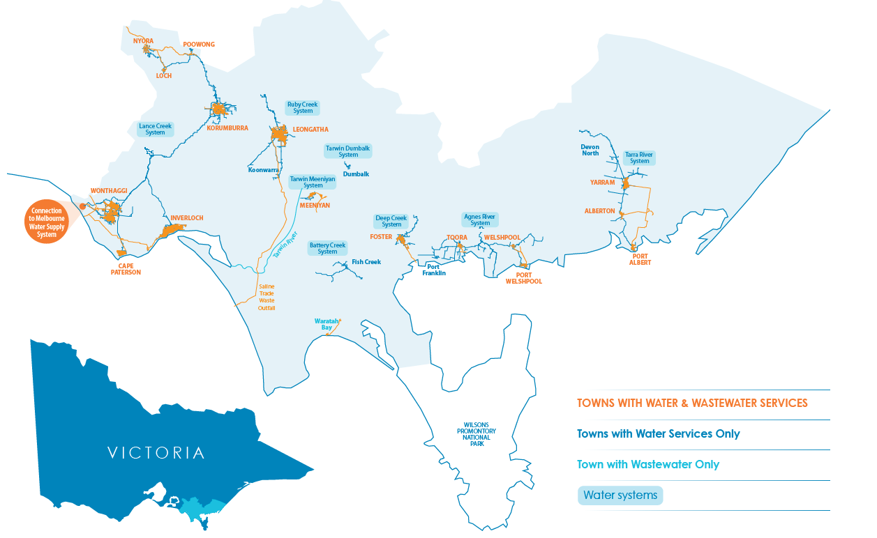
Figure 2 Locality map of SGW’s supply systems

Climate Summary

Victoria’s climate and streamflow in the longer-term context
Victoria’s climate and streamflow is highly variable, but alongside this variability we have experienced a warming and drying trend over recent decades.
In comparison to historical conditions, we are already experiencing trends toward:
- Higher temperatures and more hot days;
- Reductions in rainfall during the cooler months;
- In some locations, increases in rainfall during the warmer months and during extreme, short-duration rainfall events; and,
- In many catchments, a shift in the streamflow response to rainfall, with typically less streamflow generated for a given amount of rain.
Some of the rainfall decline in the cooler months can be attributed to increases in greenhouse gas concentrations in the atmosphere. During the cooler months we have been getting less rainfall from low pressure systems and frontal systems.
In the future, over the longer term we can expect:
- the rainfall reductions during the cooler months to persist;
- possible increases in extreme rainfall events;
- increases in potential evapotranspiration due to higher temperature and lower relative humidity;
- reductions in streamflow because of less rainfall and higher potential evapotranspiration; and
- the streamflow response to rainfall to no longer remain the same, and generally decline.
Victoria’s climate will continue to be variable with wet years and dry years, against a background drying trend. With a warmer future and projections of declining water availability, we can expect more frequent and severe droughts in coming decades and increases in extreme rainfall events.
The Victorian Government is investing in further research to better understand how Victoria’s climate is changing and the water resource implications, through the Victorian Water and Climate Initiative. More information on the observed changes and longer-term future climate and water projections can be found at:
https://www.water.vic.gov.au/our-programs/climate-change-and-victorias-water-sector

Recent Climatic Conditions in South Gippsland
Over the past 12 months, rainfall across the South Gippsland region has been well below the long-term average, as shown in Figure 3. Rainfall in most towns has been 60-80% of the Bureau of Meteorology’s long-term average (from 1961-1990), and has been the lowest on record for the 12 month period to September 2025 across much of the region, as shown in Figure 4.
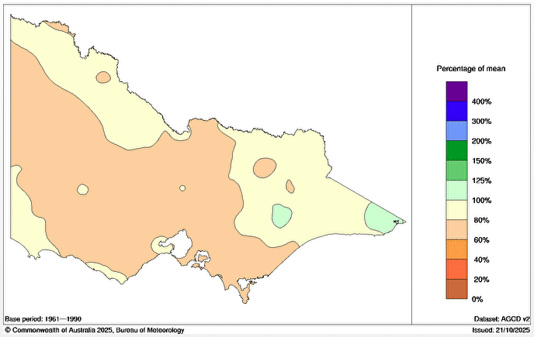
Figure 3 Rainfall percentages relative to mean over the period 1 October 2024 to 30 September 2025 (http://www.bom.gov.au/climate/maps/rainfall)

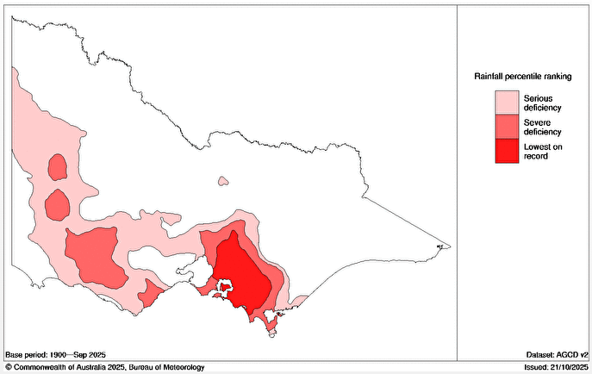
Figure 4 Rainfall deficiency relative to mean over the period 1 October 2024 to 30 September 2025 (http://www.bom.gov.au/climate/maps/rainfall)

Seasonal rainfall conditions over the past year at two representative rainfall sites in South Gippsland are shown in Figure 5 for Korumburra and Yarram. This chart compares the recent rainfall to the long term monthly average and confirms the observations made for the region above. Over the past 12 months, rainfall has been variable, but with below average rainfall in every month for the entire year at Yarram. Similarly, rainfall has also been below average at Korrumburra for almost all months of the year, with above average rainfall only occurring in July. Over winter spring (July to September 2025), rainfall across the South Gippsland region has been less than the long-term average, as shown in Figure 6.
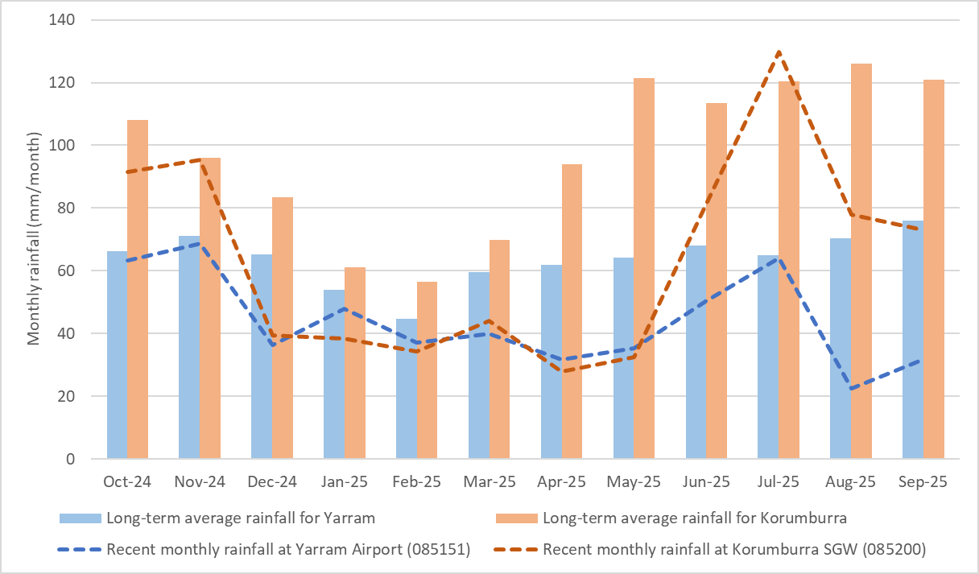
Figure 5 Recent and long-term average monthly rainfall in Korumburra and Yarram

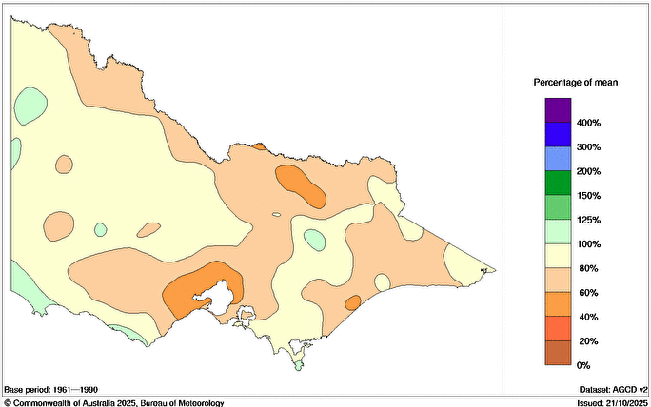
Figure 6 Rainfall percentages over the period 1 July 2025 to 30 September 2025 relative to mean (average) rainfall (http://www.bom.gov.au/climate/maps/rainfall)

A comparison of rainfall over the last 12 months relative to average annual rainfall over different climate reference periods is shown below in Table 3. Average rainfall over the period July 1975 to date is regarded by the State Government as being broadly representative of current climate averages, with the period July 1997 to date offered by the State Government as an alternative, drier representation of current climate averages.
Rainfall over the last twelve months has been 35% lower than that experienced on average at Korumburra since 1975. The last 12 months’ rainfall at Korrumburra was 7% lower than the previous lowest on record. Similarly, rainfall at Yarram over the last twelve months has been 28% lower than that experienced on average since 1975.
Table 3 Recent rainfall relative to average rainfall conditions over different historical periods
Location | Last 12 months’ rainfall  October 2024 to September 2025 (mm) | Last 12 months’ rainfall relative to…
Location |  | Average July 1975 to date | Average July 1997 to date | Lowest on record
Korumburra | 770 | 35% lower | 31% lower | 7% lower
Yarram | 530 | 28% lower | 25% lower | 20% higher

Recent Streamflow Conditions in South Gippsland
Streamflow conditions across South Gippsland are illustrated in Figure 7 using two representative streamflow sites on the Tarwin River East Branch at Dumbalk North and on the Tarra River at Fischers. This chart compares the recent streamflow observations with their long-term average monthly streamflow characteristics. It demonstrates that monthly streamflow totals were lower than average in all months over the past year (to September 2025) in the Tarwin River at Dumbalk, and below average for most months over the past year in the Tarra River. This is consistent with recent rainfall observations.
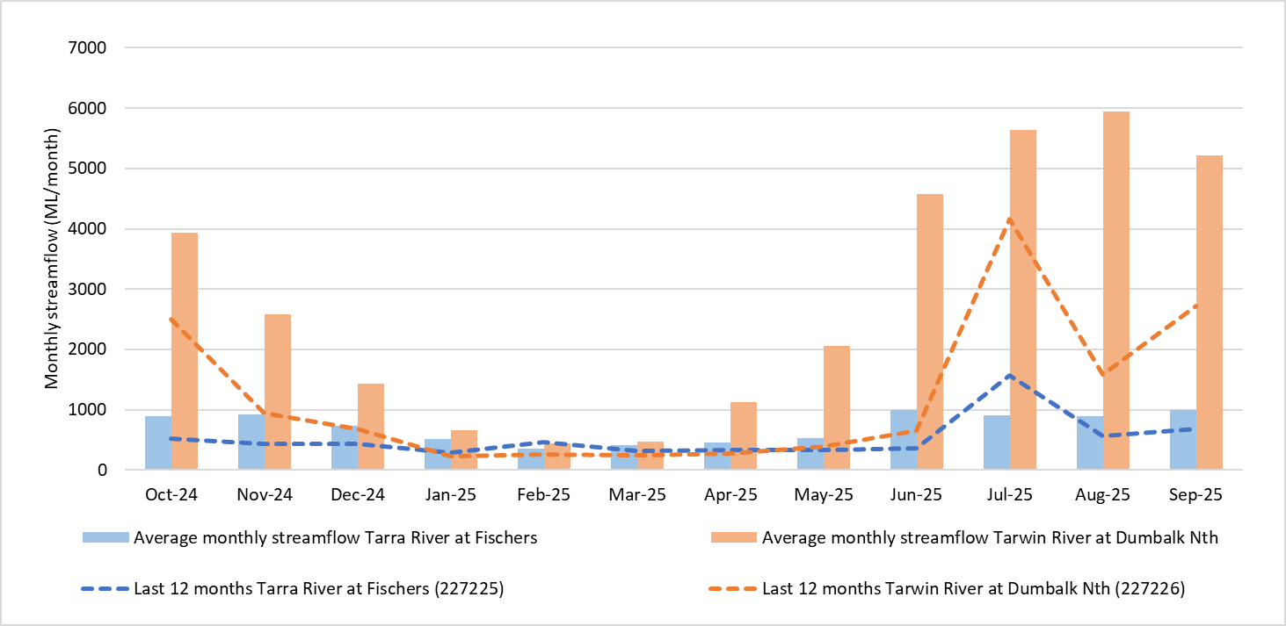
Figure 7 Recent and long-term average monthly streamflow for example sites on the Tarra River and Tarwin River

Current Water Resource Position
This section provides a summary of the current position of SGW’s water supply systems. Table 4 summarises each of SGW’s systems, with information on the major customers and water sources. For completeness, this table also provides a list of all legal entitlements, however it should be noted that not all of these water sources are actively used. Some are entitlements that would require significant infrastructure upgrades for them to be used. The year-to-date extraction volumes listed in Table 4 cover the period from the beginning of July until the end of September 2025.
A significant supply volume is also available to the Lance Creek Water Supply System from the Greater Yarra System – Thomson River Pool (Melbourne Water Supply System). South Gippsland Water has been allocated 23.9% of its entitlement from the Melbourne Water Supply System in the year to date. Based on projections by Melbourne Water, this year’s allocation is expected to increase under the forecast average climate conditions over the coming months. South Gippsland Water has also carried over 898 ML of unused allocations from previous years to the current year, providing a supply buffer in this supply system if conditions were to remain drier than expected.
In the year to date no water has been extracted from supplementary groundwater sources at Leongatha and 6 ML of supplementary groundwater supply has been provided at Yarram. The remainder of these groundwater supply sources remain in reserve and can be drawn upon if required. From February 2026, supplementary supply to Leongatha is planned to be made available temporarily from the former Korumburra storages. This will aim to mitigate the severity of water restrictions within these towns during 2026, which has become likely following drier than average conditions impacting Leongatha’s reservoir volumes over the past 12 months.

Table 4 System Summary – Water Supply Connections, Major Customers and Available Entitlements
Supply System | Towns Supplied | Number of connections | Major customers | Primary Bulk Entitlement |  |  | Supplementary water sources
 |  |  |  | Annual entitlement (ML) | Volume extracted 2025-26 YTD (ML) | Volume remaining 2025-26 (ML) | Annual entitlement  (ML) | Volume extracted 2024-25 YTD (ML)
Ruby Creek | Leongatha, Koonwarra | 3,436 | Saputo Dairy Australia | 2,476 | 361 ML | 2,115 ML | Share of 715.3 ML from groundwater | 0
Lance Creek | Wonthaggi, Cape Paterson, Inverloch, Korumburra, Poowong, Loch, Nyora | 14,404 | Burra Foods Australia, Kilcoy Global Foods, and GBP Australia | 3,800 ML from Lance Creek Reservoir | 320 ML from Lance Ck | 3,480 ML from Lance Creek | 1,000 ML* from Melbourne Water Supply System: 23.9% year to date seasonal allocation (169 ML) plus 898 ML (net) carried over from previous year | 729 ML from Melbourne Water Supply System
Tarwin River East Branch | Dumbalk | 109 |  | 100 | 7 ML | 93 ML
Tarwin River | Meeniyan | 278 |  | 200 | 12 ML | 188 ML
Deep Creek / Foster Dam | Foster | 953 |  | 326 | 55 ML | 271 ML
Battery Creek | Fish Creek | 209 |  | 251 | 26 ML | 225 ML
Agnes River | Toora, Welshpool, Port Welshpool, Port Franklin, Barry Beach Port | 1,133 | Esso, ViPlus | 1,617 | 131 ML | 1,486 ML
Tarra River | Yarram, Alberton, Port Albert, Devon North | 1,883 |  | 853 | 100 ML | 753 ML | 214.2 ML from groundwater | 6 ML
*plus access to more water via water trading from the Melbourne Water Supply System from July 2026, if needed.

The volume in storage across the SGW systems is summarised in Table 5. All storages are currently full, except Lance Creek Reservoir, and the Leongatha storages. Western Reservoir in the Leongatha supply system is drawn down to 26% of fully supply volume and Lance Creek Reservoir is 63% of full supply volume.
Table 5 Current Water Resource Position
Supply System | Storage | Storage capacity (ML) | Current storage volume (ML) at end October 2025 | % of Full Supply Volume
Little Bass | Little Bass Reservoir ⁽¹⁾ | 218 | N/A | N/A
Korumburra | Coalition Creek Reservoir ⁽¹⁾ | 143 | 71 | 50%⁽¹⁾
Korumburra | Ness Gully Reservoir ⁽¹⁾ | 73 | 0 | N/A
Korumburra | Bellview Creek Reservoir | 359 | 359 | 100%
Leongatha | Western Reservoir | 1,137 | 709 | 62%
Leongatha | Hyland Reservoir | 671 | 668 | 99%
Leongatha | No.2 Reservoir | 84 | 70 | 83%
Leongatha | No.1 Reservoir | 15 | 15 | 79%
Lance Creek | Lance Creek Reservoir | 4,200 | 2,650 | 63%
Fish Creek | Battery Creek Reservoir | 119 | 119 | 100%
Foster | Deep Creek Reservoir | 5 | 5 | 100%
Foster | Foster Dam | 200.5 | 200.5 | 100%
Foster | Raw Water Basin | 27 | 27 | 100%
Agnes River | Cook’s Dam | 59 | 59 | 100%
Agnes River | Raw Water Basin⁽¹⁾ | 30 | N/A | N/A
Tarra River | Yarram Basin | 30 | 30 | 100%
⁽¹⁾ storage not in use, other than for minor supply to non-urban customers. These storages are currently maintained at target operational water levels below full supply volume.
N/A = not applicable.
The volume of water consumed over the year to date is compared to the average demand over the past five years for each system in Figure 8 to Figure 15. Comparisons of demand to previous climate forecast projections are depicted in Figure 16 to Figure 23. There have been recent increased demands at Dumbalk due to an improvement to water pressure resulting in higher residential demand. Demand has increased rapidly in the short-term within our 3 easternmost townships, Foster, Toora and Yarram. This is expected to be primarily due to agricultural water demand increasing as a result of dry conditions experienced within the past 2 years. Additionally, Foster is SGW’s most utilised customer standpipe, and impacted by an increased demand for water deliveries that comes with drier conditions. Lance Creek System demands have been also consistently above average in the year to date, which is partly due to increased water use from a major industrial customer. Assumed demand for Leongatha has been reduced in the storage outlook, relative to previous years, due to a reduction in recent historical and forecast water consumption by a major industrial customer in that supply system. Major industrial customer demand at Leongatha in the year to date has been approximately 25% lower than the 5 year average for this time of year.
As a response to known demand changes and Lance Creek and Leongatha reservoirs operating at lower than typical for much of 2025, water restriction trigger volumes have been revised. This is to ensure that timeframes for drought responses remain as up to date as possible if these supply systems were to experience dry conditions again in upcoming years.
Consumption for all other supply systems is expected to be close to the long-term average for the remainder of the year. Demand in all supply systems typically increases in summer due to the warmer weather. It also increases in summer in the Lance Creek System as a result of visitors to the Bass Coast, particularly at Inverloch and Cape Paterson.
The Urban Water Strategy provides further information on the expected growth in residential, stock and domestic, major industrial and other non-residential demands over a long-term (50 year) planning horizon for a range of possible future climate scenarios. South Gippsland Water tracks water use on an ongoing basis to monitor for growth.
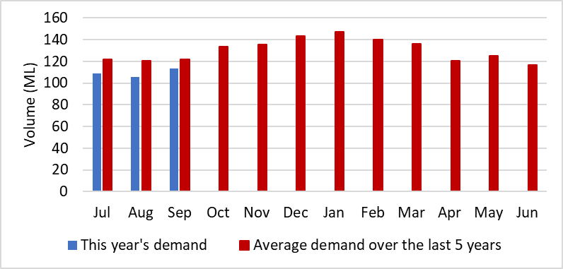
Figure 8 Water consumption in Leongatha

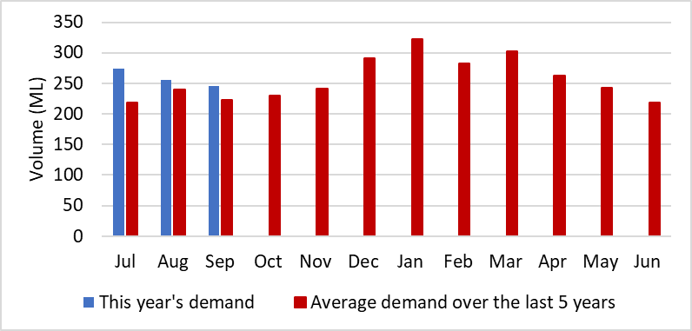
Figure 9 Water consumption in the Lance Creek system

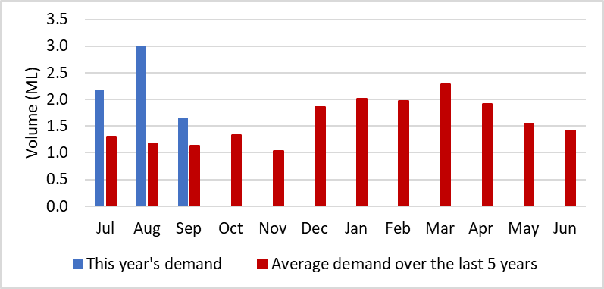
Figure 10 Water consumption in Dumbalk

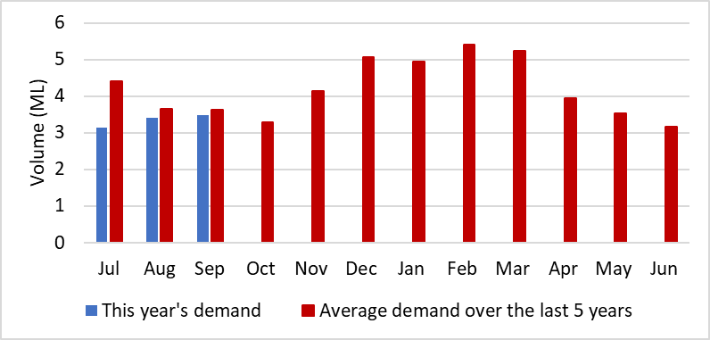
Figure 11 Water consumption in Meeniyan

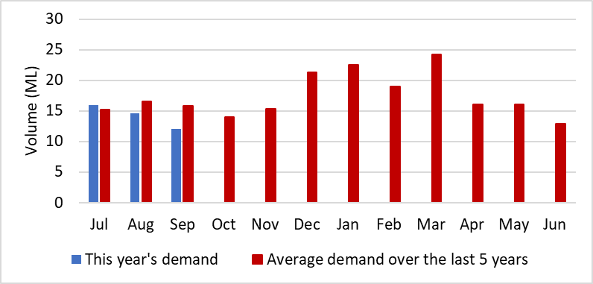
Figure 12 Water consumption in Foster

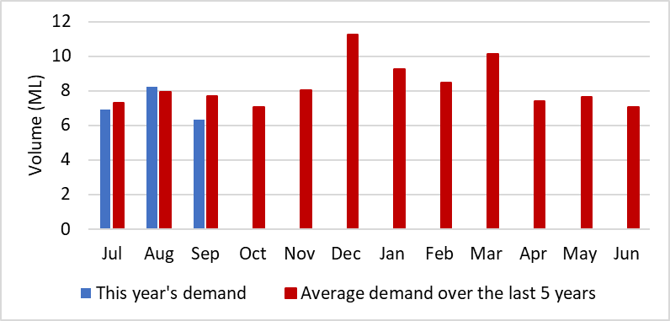
Figure 13 Water consumption in Fish Creek

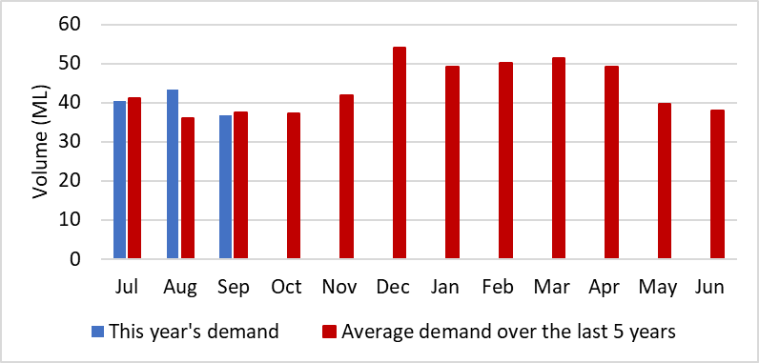
Figure 14 Water consumption in Toora

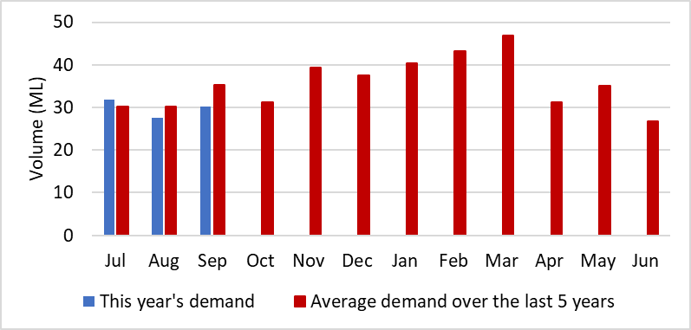
Figure 15 Water consumption in Yarram

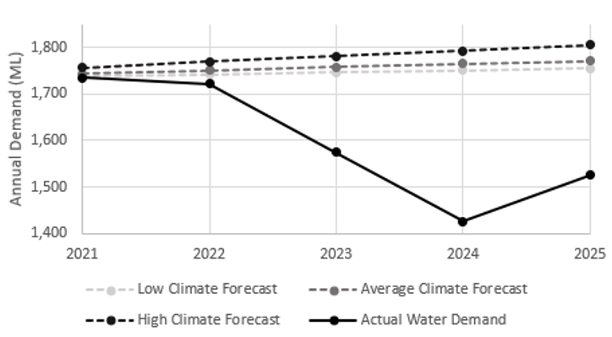
Figure 16 Recent water demand vs previous forecast projections in Leongatha

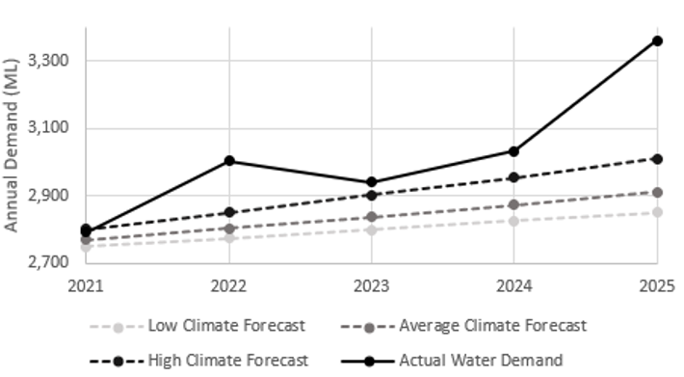
Figure 17 Recent water demand vs previous forecast projections in Lance Creek

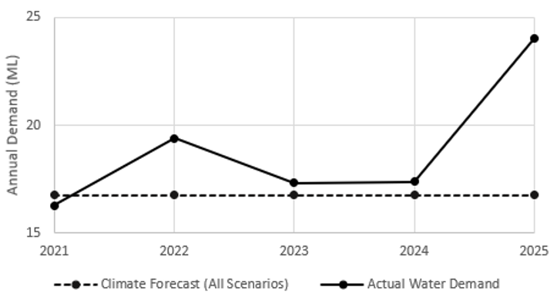
Figure 18 Recent water demand vs previous forecast projections in Dumbalk

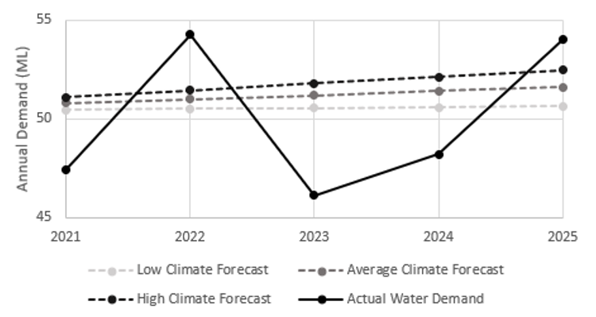
Figure 19 Recent water demand vs previous forecast projections in Meeniyan

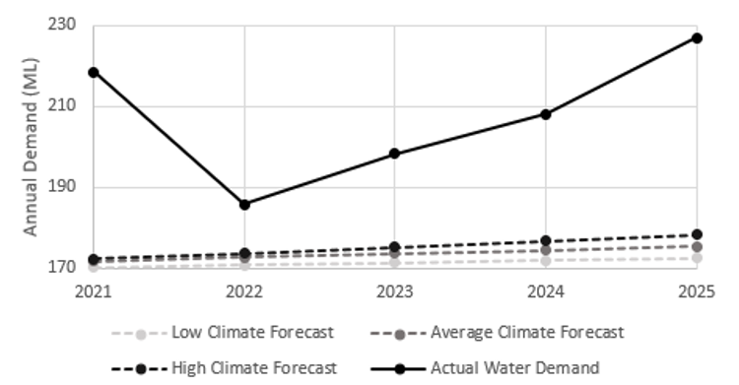

Figure 20 Recent water demand vs previous forecast projections in Foster

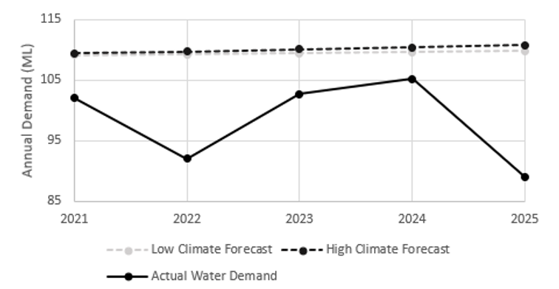
Figure 21 Recent water demand vs previous forecast projections in Fish Creek

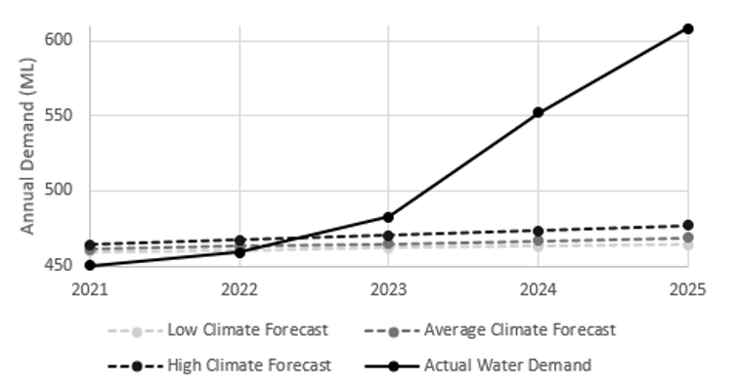
Figure 22 Recent water demand vs previous forecast projections in Toora

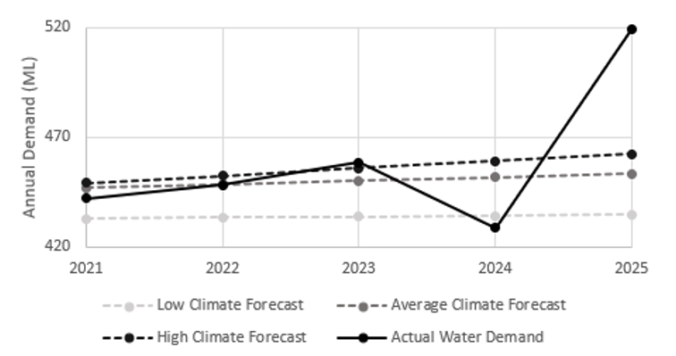

Figure 23 Recent water demand vs previous forecast projections in Yarram

Climate Outlook
The Bureau of Meteorology’s seasonal climate forecasts have been obtained for the December to February three-month period.
Across the region, there is a high degree of uncertainty of the rainfall forecast from December to February, driven by opposing climate drivers. Rainfall is expected to be similar to the long-term median rainfall in the South Gippsland region (as shown in Figure 24).
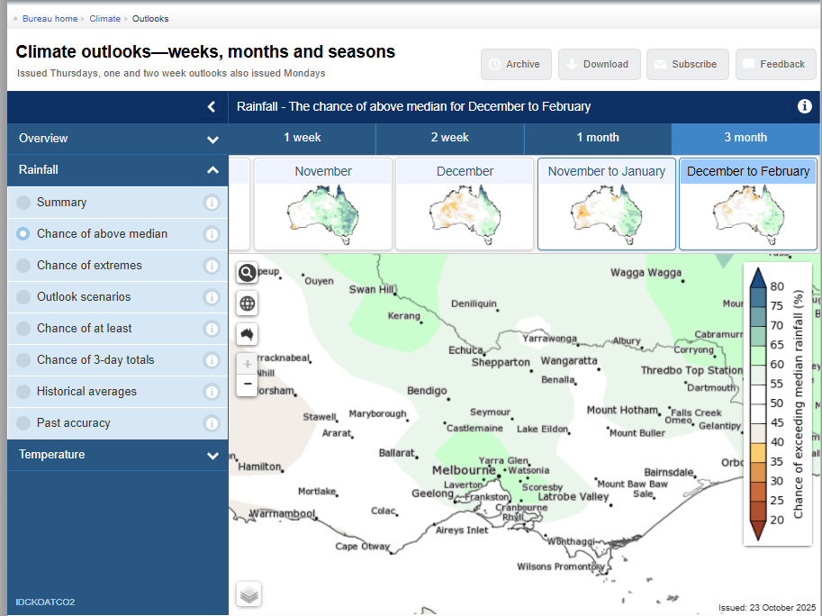
Figure 24 Chance of above median rainfall for December to February (http://www.bom.gov.au/climate/ahead/) issued 23 October 2025

The maximum daytime temperature across the region is forecast to be hotter than usual from December to February, as indicated in Figure 25. The there is an 80% likelihood of above median temperatures across all of South Gippsland.
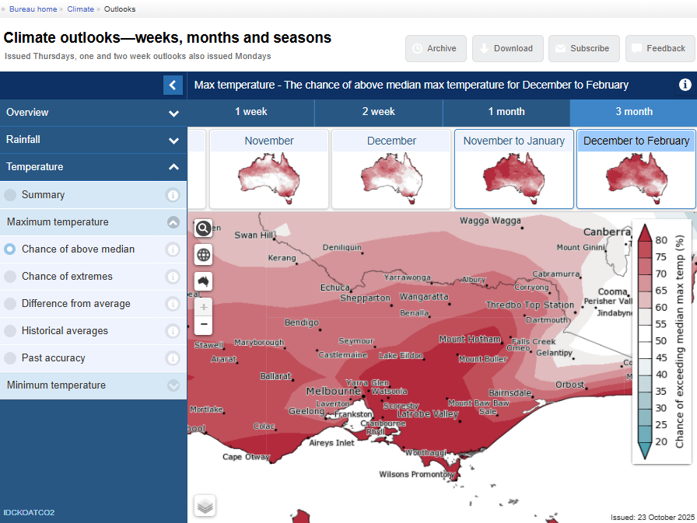
Figure 25 Chance of above median maximum temperature for December to February (http://www.bom.gov.au/climate/ahead/) issued 23 October 2025
The forecast climate conditions for South Gippsland have been developed based on the Bureau’s forecast for the region and the local climate conditions in the year to date. Table 6 summarises the climate outlook across SGW’s systems and specifies the scenario assumed for the Annual Water Outlook for each system, based on the assumption that:
- Wet conditions have >80% chance of exceeding median rainfall
- Average conditions have >40% to <80% chance of exceeding median rainfall
- Dry conditions have <40% chance of exceeding median rainfall
Climate influences on south-eastern Australia this year:
- Warmer oceans can provide increased moisture and energy, that can enhance the severity of storms, cyclones and rain systems. Forecasts for November to January show warmer-than-average sea surface temperatures are likely around most of Australia, especially to the south-east.
- The El Niño–Southern Oscillation (ENSO) is neutral. The Bureau's model predicts sea surface temperatures in the tropical Pacific are likely to just meet La Niña levels during spring (typically associated with wetter conditions in southern Australia), before returning to neutral during summer. This timing aligns with most international models assessed, although they generally show more cooling in the central tropical Pacific compared to the Bureau's model. An atmospheric response has been limited to date.
- A negative phase of the Indian Ocean Dipole (IOD) is underway. The Bureau's model predicts the negative IOD event to continue throughout spring, with a return to neutral in early summer, consistent with all international models. A negative IOD is typically associated with above average winter-spring rainfall across southern Australia.
- A sudden stratospheric warming event occurred in September 2025. These events, where air temperatures in the stratosphere around Antarctica suddenly and dramatically warm, are relatively rare. The last event occurred in 2019, when Victoria experienced the so-called “Tinderbox Drought” that resulted in low rainfall across SGW’s supply areas.
- The Bureau incorporates these events into its forecast models and outlooks.
With the Bureau of Meteorology forecast for an even (50-55%) chance of exceeding median rainfall conditions, neutral ENSO and negative to neutral IOD, SGW are adopting an “average” climate outlook.
Table 6 Climate outlook across SGW systems
Supply System | Towns supplied | Bureau of Meteorology Forecast (Nov-Jan) |  | Winter and spring rainfall for 2024 year to date | Likely Outlook Scenario
Supply System | Towns supplied | Chance of exceeding median rainfall | Chance of exceeding median maximum temperature | Winter and spring rainfall for 2024 year to date | Likely Outlook Scenario
Ruby Creek | Leongatha, Koonwarra | 50-55% | Greater than 80% | Less than Average | Average
Lance Creek | Wonthaggi, Cape Paterson, Inverloch, Korumburra, Poowong, Loch, Nyora | 50-55% | Greater than 80% | Less than average | Average
Tarwin River East Branch | Dumbalk | 50-55% | Greater than 80% | Less than Average | Average
Tarwin River | Meeniyan | 50-55% | Greater than 80% | Less than average | Average
Deep Creek / Foster Dam | Foster | 50-55% | Greater than 80% | Less than Average | Average
Battery Creek | Fish Creek | 50-55% | Greater than 80% | Less than average | Average
Agnes River | Toora, Welshpool, Port Welshpool, Port Franklin | 50-55% | Greater than 80% | Less than Average | Average
Tarra River | Yarram, Alberton, Port Albert, Devon North | 50-55% | Greater than 80% | Less than average | Average

Forward Outlook
The urban water restrictions outlook for SGW’s supply systems are based on consideration of the information presented in each of the previous sections, in combination with an assessment of the projected storage behaviour over the coming year based on modelled information. For run-of-river systems, streamflow is projected for the coming three months.
Table 7 summarises SGW’s assessment of the likelihood of water restrictions for each of its supply systems over the outlook period specified in the Annual Water Outlook. For systems with no storage, the outlook period is 3 months (updated system outlooks to be provided in March 2026), and for systems with available storage, the outlook period is 12 months. Forecasts for supply systems with low storage capacity relative to demands (i.e. the run-of-river systems) have a greater level of uncertainty than the forecasts for supply systems with considerable storage. Therefore, the likelihood of restrictions for Dumbalk, Meeniyan and Yarram will be reviewed throughout the year. The assessment presented in Table 7 utilises the rating system (Table 8) provided in the State Government’s 2025 Annual Water Outlook Guidelines for Urban Water Corporations.
The following general statements can be made about the SGW systems, as informed by the supply system forecasts in Figure 26 to Figure 33. In these “average climate scenario” refers to a 50th percentile scenario (equally likely to be above or below this line), and “dry climate scenario” refers to a 90th percentile scenario (occurs in roughly one year out of every ten). These figures illustrate projected storage or streamflow behaviour over the outlook period under the forecast average climate conditions:
- Restrictions are not considered likely or certain for all supply systems.
- There had been concern in recent months that Leongatha would be a risk of restrictions in 2026, initial forecasting in this report was that up to Stage 2 restrictions were likely in late-summer & autumn. However well above average November rainfall has significantly improved storage levels, and forecasting was revised to verify that restrictions are now unlikely to occur in Leongatha during 2026.
- Temporary connection of Korumburra’s former supply dams to Leongatha commenced in October 2025 to provide a supplementary supply source, and remains ongoing despite recent rainfall, as a safeguard against further dry conditions in the short-term. This will be able to provide at least 430ML of additional volume, or 3-4 months’ worth of supply, to Leongatha throughout the year. This connection will also increase Leongatha’s harvestable catchment area from 9km² to 13km² for upcoming years. Groundwater entitlements remain available, but are only likely to be used to prevent the onset of Stage 4 water restrictions, due to the high costs required to reinstate these as viable supply resources.
- For Fish Creek, restrictions are not expected under the anticipated average climate scenario, but could still be possible in late summer and autumn if conditions were to become drier than anticipated. Fish Creek (Battery Creek Storage) is a small system and can change quickly, both in response to rainfall, and in the event of sustained dry conditions for only a few months. The neighbouring Foster water supply system has greater security and would be able to supplement Fish Creek if needed. Unrestrictable demand could be met through water carting, mitigating the likelihood of Stage 3-4 restrictions being required, but pipeline connection is also feasible as a long-term security measure (UWS Action 7.19).
- For Toora, the likelihood of restrictions is assessed as rare, with restrictions projected to only occur if conditions were to become drier than indicated by the Bureau of Meteorology’s climate forecast and recent climate conditions. The neighbouring Foster water supply system has greater security and would be able to partially supplement Toora through water carting or temporary pipeline transfer to delay the onset of Stage 4 restrictions during periods of sustained low river flows. In the long-term, establishing an off-stream storage, or reinstating Toora’s raw water basin will improve drought resiliency (UWS Action 7.14).
- The systems with low storage capacity relative to demands (Dumbalk, Meeniyan and Yarram) have been assigned a restriction likelihood of very rare, as the recent streamflow conditions, as well as the forecast climate conditions, suggest streamflows will remain above average and well above South Gippsland Water’s restriction triggers.
Figure 26 to Figure 33 also show how storages and streamflows could behave if conditions were to become considerably drier than forecast. The average, dry and worst drought on record scenarios in these figures for the storage projections are assigned based on the minimum storage volume estimated to be reached over the 12 month outlook period. For the streamflow outlooks the dry, average and wet streamflow forecasts are assigned based on streamflows with a likelihood 10% lower, the same or 10% higher than the observed likelihood of streamflows in the year to date.

Table 7 Risk Assessment Likelihood rating for water restrictions over the 2025/26 Outlook period
Supply Sources | Towns Supplied | Outlook Period | Likelihood of Restrictions⁽¹⁾
Ruby Creek Reservoirs | Leongatha, Koonwarra | 1 Nov 2025 to 31 Oct 2026 (12 months) | Unlikely
Lance Creek Reservoir and the Melbourne Water Supply System | Wonthaggi, Cape Paterson, Inverloch, Korumburra, Poowong, Loch, Nyora | 1 Nov 2025 to 31 Oct 2026 (12 months) | Very Rare
Tarwin River East Branch | Dumbalk | 1 Nov 2025 to 31 Jan 2026 (3 months) | Very Rare (to end of Jan 2026)
Tarwin River | Meeniyan | 1 Nov 2025 to 31 Jan 2026 (3 months) | Very Rare (to end of Jan 2026)
Deep Creek Reservoir and Foster Dam | Foster | 1 Nov 2025 to 31 Oct 2026 (12 months) | Very Rare
Battery Creek Reservoir | Fish Creek | 1 Nov 2025 to 31 Oct 2026 (12 months) | Possible
Cook’s Dam (Agnes River) | Toora, Welshpool, Port Welshpool, Port Franklin, Barry Beach | 1 Nov 2025 to 31 Oct 2026 (12 months) | Rare
Tarra River and groundwater | Yarram, Alberton, Port Albert, Devon North | 1 Nov 2025 to 31 Jan 2026 (3 months) | Very Rare (to end of Jan 2026)
⁽¹⁾ Explanation of the likelihood classification is available in Table 8

Table 8 Risk Assessment Likelihood Rating (Source: Victorian State Government, Department of Energy, Environment and Climate Action)
Likelihood Rating | % | Description
1 Very Rare | < 1 | Event may occur only in extraordinary circumstances
2 Rare | 1-4 | Event may occur only in exceptional circumstances
3 Unlikely | 5-19 | Event could occur at some time  There is little opportunity, reason or means to occur
4 Possible | 20-49 | Event might occur  There is some opportunity, reason or means to occur
5 Likely | 50-79 | The event is likely to occur in most circumstances  There is considerable opportunity, reason or means for the event to occur
6 Almost Certain | 80-100 | Event is expected to occur in most circumstances  There is great opportunity, reason or means to occur

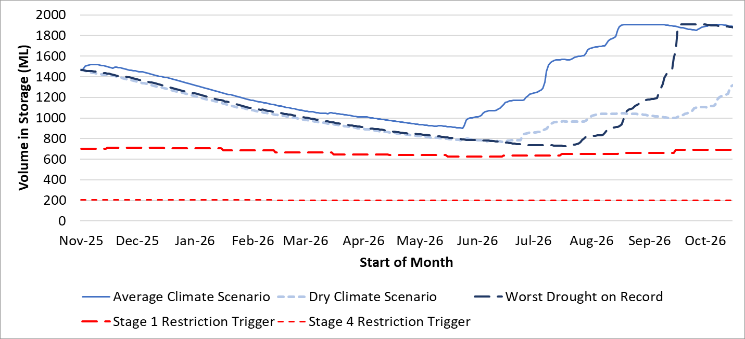
Figure 26 Urban water restrictions outlook for Leongatha

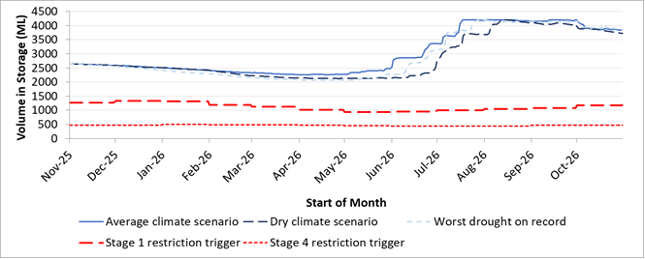
Figure 27 Urban water restrictions outlook for the Lance Creek system

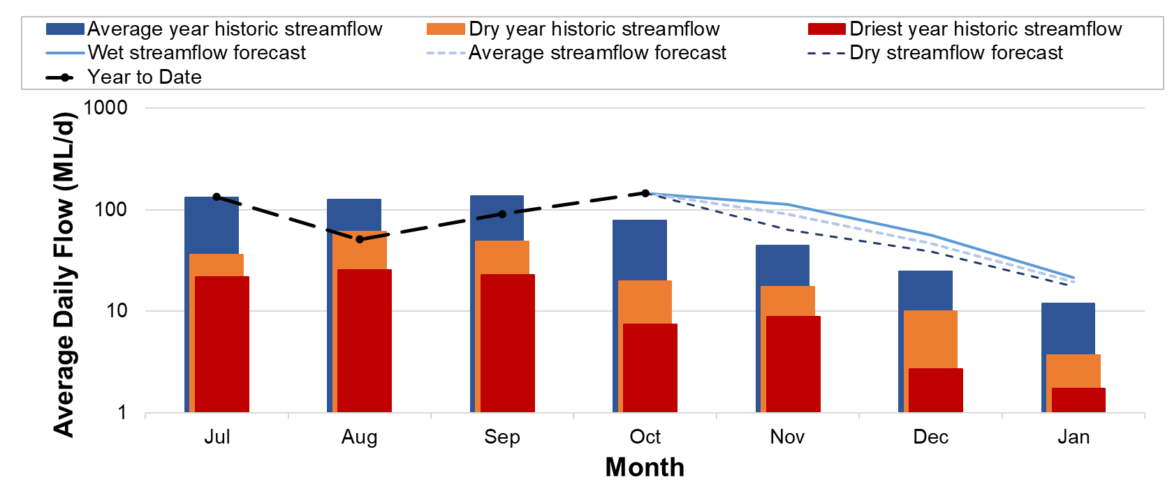
Figure 28 Streamflow outlook for Dumbalk

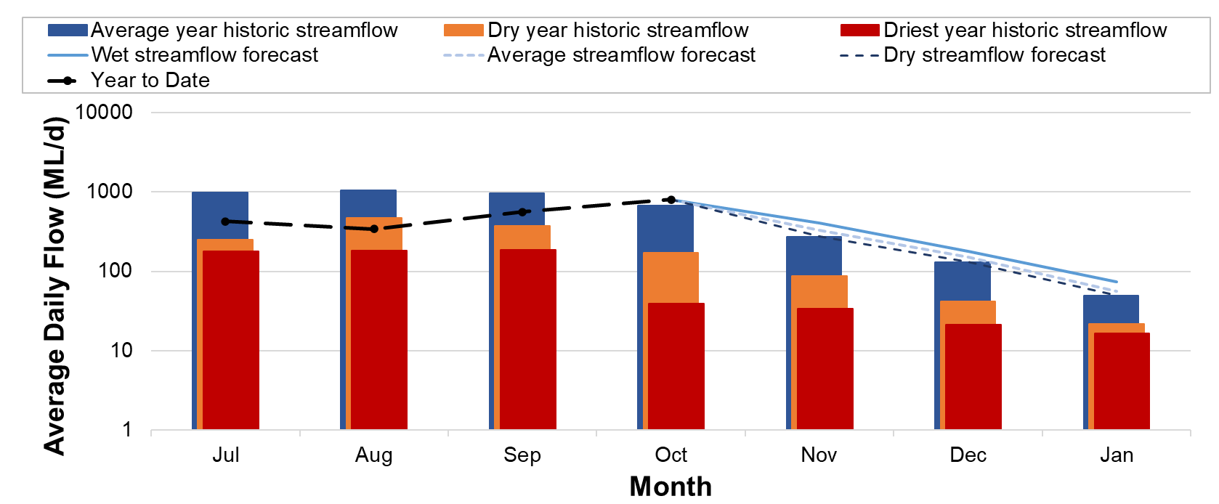
Figure 29 Streamflow outlook for Meeniyan

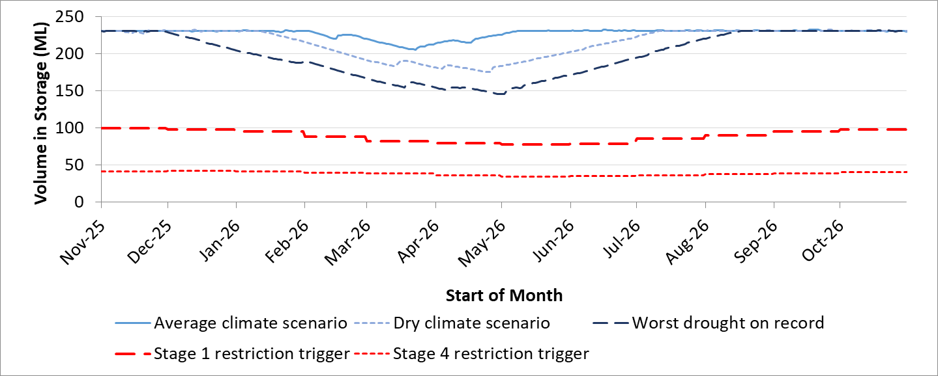
Figure 30 Urban water restrictions outlook for Foster

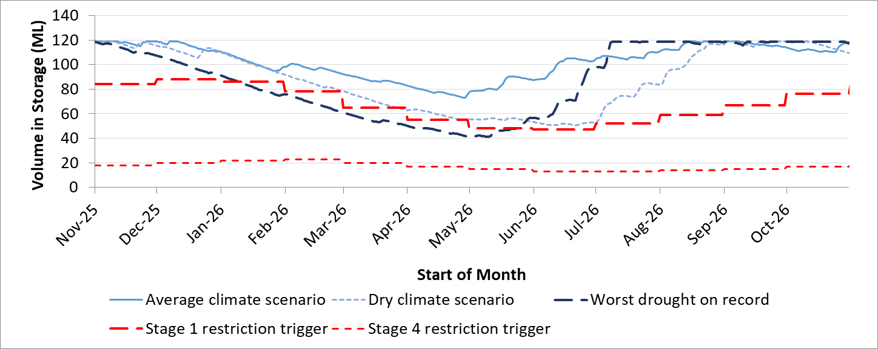
Figure 31 Urban water restrictions outlook for Fish Creek

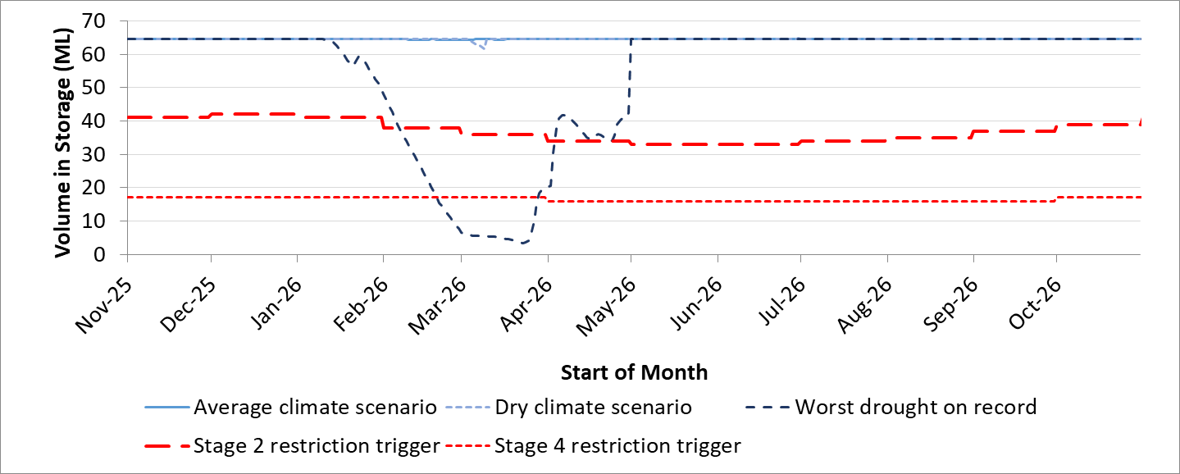
Figure 32 Urban water restrictions outlook for Toora

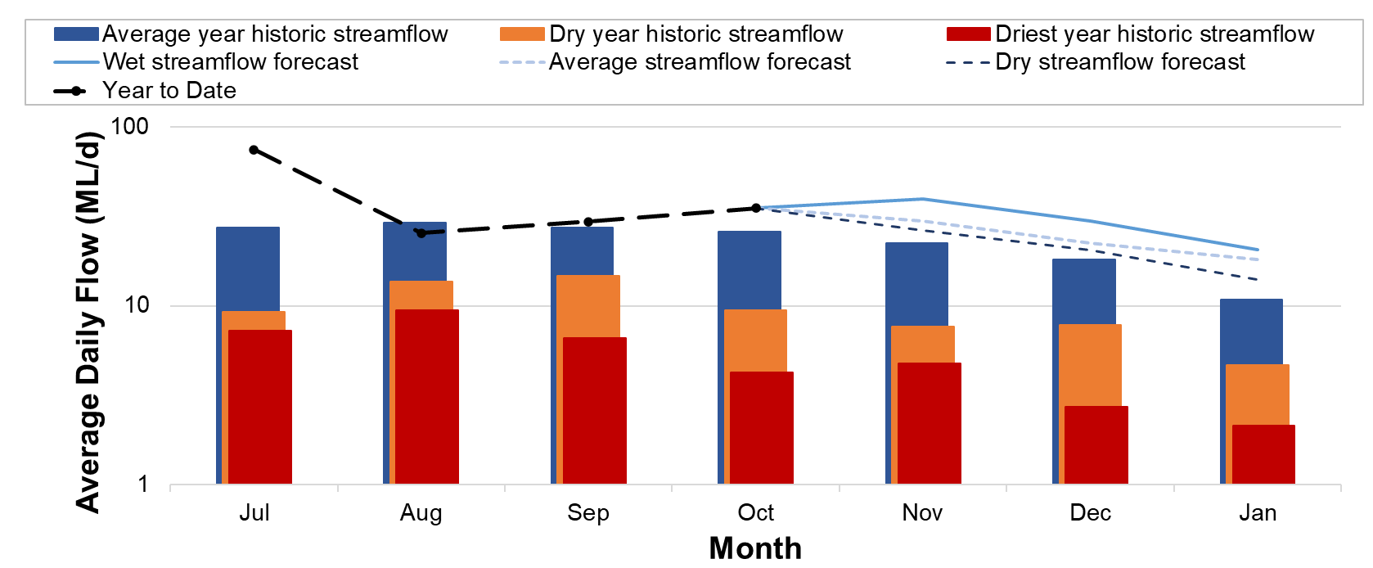
Figure 33 Streamflow outlook for Yarram

Short Term Action Plan
A list of priority actions for each of SGW’s supply systems, prior to the next update of the Urban Water Strategy in 2027, is provided in Table 9. Further information on actions can be found in the Urban Water Strategy and SGW’s Price Submission 2023-2028 publication on our website.
The 2022 UWS includes 60 actions, of which SGW has completed 9 to date. A further 36 of these actions are currently underway. Action 4.1, to confirm our strategy for purchase of additional Bulk Water Entitlement from Melbourne Water has been delayed by proposed legislation which could alter the ways in which water can be accessed through Melbourne Water’s headworks in the future.
Action 4.14, an investigation into feasibility of digital meters to customers in Fish Creek to understand leakage and non-revenue water losses has been undertaken, with actions to mitigate water losses rescheduled. SGW are set to begin an investigation into non-revenue water. This will take an overall approach for all supply systems, aim to identify and quantify non-revenue water within each system and implement strategies to reduce non-revenue water volumes in a staged approach.
Actions for the Ruby Creek Supply system have all been reassessed in 2025, as dry conditions resulted in Leongatha’s reservoir volumes being below typical storage volumes for much of the year. Action 7.16, connection to the Lance Creek system, is preferred as a long-term approach to secure supply. However, Action 7.1, implementing connection to Korumburra’s disused Bellview Creek and Coalition Creek reservoirs, is being modified as an interim supplementary supply connection and set to be completed in early 2026.

Table 9 Priority Action Plan

System | Action | Due date | Status | Comments
Ruby Creek water system | Renew infrastructure to continue use of Condolucci, Wild Dog, Van Ecks & Racecourse Rd groundwater bores | 2027 | Completed | Scope, design, cost estimates completed. Reinstating bores identified as high cost per ML and no longer preferred approach to Leongatha water security.
Ruby Creek water system | Investigate feasibility of interconnection of disused dams to the Ruby Creek system | 2027 | In Progress | Connection to the Lance Creek supply system (and Melbourne Water Supply Grid & Victorian Desalination Plant by extension) is now our preferred option to supplement Leongatha in the long term. However, interconnection of disused dams will instead be implemented as an interim supplementary supply until permanent Lance Creek connection becomes feasible.
Ruby Creek water system | Investigate feasibility of digital meters with a target of transfer main leak detection and understanding larger water consumption customers | 2027 | In Progress | Additional metering installed to increase monitoring of flows/losses within Leongatha’s raw water transfer main
Lance Creek water system | Confirm strategy & Purchase additional Bulk Water Entitlement from Melbourne water supply system | 2024 | In Progress/ Rescheduled | Rescheduled as this may be impacted by proposed legislation.
Battery Creek water system | Investigate feasibility of digital meters to customers in Fish Creek to understand leakage and non-revenue water losses: Estimated 20% reduction in water losses. | 2023 | Rescheduled | Non-revenue water losses investigation now taking a wider focus across all SGW supply systems
Agnes River Supply System | Implement infrastructure to reuse wash water at Toora Water Treatment Plant | 2027 | In Progress | Design is underway
All Water Systems | Review and compare consumption data for accuracy and trends | Ongoing | Ongoing | Ongoing through annual reporting cycles, to be used in project works to reduce non-revenue water
All Water Systems | Review long-term trends in water use independent of climate variability | Ongoing | Ongoing | Water restriction triggers updated in 2025 for Lance Creek and Leongatha supply systems
All Water Systems | Monitor major industry demand, keep informed of usage including water efficiency programs | Ongoing | Ongoing | Continuing to track, increased consultation in response to drier conditions in first half of 2025
All Water Systems | Water efficiency via community programs, grants and education | Ongoing | Ongoing | All continuing through public fountain installations, sponsorships and in-kind support at events.
All Water Systems | Support larger residential and commercial properties assess rainwater and reuse systems | Ongoing | Ongoing | Supported farmers with water reuse as potential alternative resources during drier conditions in first half of 2025
All Water Systems | Continue system leakage reduction and unmetered connection programs | Ongoing | Ongoing | Project commencing to take a staged approach to non-revenue water

Victoria’s permanent water savings rules are always in place in South Gippsland, saving water on an ongoing basis.
- Always water your garden using a leak-free hose with a trigger nozzle.
- Sprinklers and drippers can only be used before 10am and after 6pm.
- Don't hose concrete, paths or driveways - use a broom instead.
- Fountains and water features must recirculate water.
For additional tips about how to save water see our smart water advice.

