Sewer Blockages Procedure
Please follow this procedure when rectifying a sewer blockage. It will ensure you gain a clear understanding of your area of ownership and responsibilities of the property drain. It also outlines your responsibilities associated with trees and structures over property drains and South Gippsland Water (SGW) assets.

For Plumbers, this procedure clearly determines the responsibility for a sewer blockage occurring in the property or within SGW’s asset. Plumbers will be supplied with a field response protocol if they wish to apply to SGW for reimbursement of costs associated with clearing sewer blockages.

SGW Officers can make a determination of responsibility that is based on a transparent and structured policy.

- Step by step process for sewer blockages
The following is a general overview of the sewer blockage procedure.

Failure to follow this procedure may result in rejection of all or part of any claim submitted to SGW:

- When a plumber receives a call from a customer to “clear the blockage”;
- If the plumber determines the blockage may be outside of the customer boundary, they must contact SGW and request site plans and any other relevant information. These reference materials should include “property sewer plans” (submission of these will be required for SGW to consider reimbursement).
- If the plumber is unable to determine where the blockage is, SGW should be requested to attend the site and undertake a sewer main inspection.
- If the main is clear, the plumber continues work to “clear the blockage” as requested by the customer.
- If the plumber clears the blockage and they believe the blockage was within an SGW asset, they must inform SGW at the time of the determination and obtain a work-order number for reference.
The work-order number that is issued is only a reference for future auditing and is not a purchase order number or a guarantee of payment.

Plumbers should not carry out works they are not trained, experienced and competent to do. This may include but is not limited to:

- Excavation and trenching techniques
- Trench safety
- Confined spaces entry
- Plant operations
- Plant maintenance
- Traffic and pedestrian management
- Fall prevention
- Work on SGW assets

If working near SGW assets, SGW should be contacted prior to the execution of works that involve the above risks on 1300 851 636.

- At all times, the plumber must be cautious of interpreting and communicating responsibility for a blockage to the customer. Until an audit has been conducted by SGW, responsibility for payment cannot be determined.
- Plumbers must pay attention to “blockage caused by owners trees”, “structures over connection point” and “combined drains” as responsibility may impact on the claim.
- Plumbers are not to advise customers that SGW will/will not perform an audit/CCTV inspection at the property drain or connection point. An audit or CCTV inspection is at SGW discretion.
- Reimbursement by SGW will only occur after an audit of the works is conducted confirming the responsibility for “clearance of the blockage” was SGW responsibility. The plumber must supply, as part of this claim, the following data to allow for an audit to occur.
- South Gippsland Water Audits
Customer or Plumbing contractor reimbursement:

Prior to any reimbursement being considered or approved, an audit is to be conducted by SGW Maintenance department. A SGW maintenance technician will check the relevant design and as-built plans of the customer’s house drain and undertake a visit to the site to verify the claim. This may also require inspection by CCTV camera at the cost of SGW.

The following check list items must be satisfied for reimbursement of costs:

- Did the Plumbing Contractor or the Customer request SGW to check the main for blockages prior to commencing work?

- Did SGW advise the Plumbing Contractor or the Customer whether the main is clear and if so, it is then the owner’s responsibility?

- Should the Plumbing Contractor believe they have located the blockage beyond the owner’s area of responsibility after “rodding” the drain, the Plumbing Contractor should stop work and notify SGW, who will advise to either (1) leave the job or (2) continue clearing the blockage on behalf of the customer.

- If the plumber is not willing to proceed with the clearance, reimbursement may not be considered as they have not fulfilled the engaged task of “clearing the blockage”.

What SGW will not pay for
- Clearing the customer pipes
- Digs to find your inspection point or boundary trap
- Installation of inspection shaft
- Any works performed by the plumber not related to an SGW area of responsibility

The property owner will pay for the cost of works where:
- The plumber didn’t refer the blockage to SGW
- All work carried out by the plumber which relates to clearance and/or work on your sewer assets
- CCTV was used to determine a blockage location, unless agreed to by SGW
- Costs including the use of general accessories (machine hire, for example)
- A high-pressure water jet cleaner was used
- Tree roots were cleared, or chemicals added to dissolve the blockage

To assist the plumber in supplying SGW with the required information, a “REQUEST FOR REIMBURSEMENT CLAIM FORM” is included at the end of this document.

Frequently Asked Questions:

- What will SGW reimburse?
Once SGW has received the ‘request for reimbursement claim form’, the claim will be assessed and you will be notified of the outcome. SGW will normally reimburse the call out fee and first hour of work for the plumber to locate and expose the inspection shaft. Where the costs associated with determining where the blockage was, a claim for reimbursement for fair and reasonable costs associated with a plumber's call out is applicable. In investigating the blockage, the plumber must perform best practice to determine the location of the blockage

- Whose responsibility is it to maintain access to sewer inspection points?
It is the responsibility of the landholder to maintain any inspection points within their property boundary. If you call SGW to clear a blockage and your inspection shaft is buried, a SGW Maintenance Technician will ask you to arrange works to raise the point to surface level.

- What will happen if my plumber does not obtain a property sewer plan?
If the plumber does not contact SGW to request a property sewer plan, reimbursement of costs may not be applicable. Landholders can also obtain any property sewer plans that are relevant to their property.

- How can I tell if the blockage is in the sewer main or my internal plumbing?
If you suspect a blockage, you will need to contact a plumber so they can determine if the blockage is in the main or the sewer sideline. If the blockage is determined to be in the in the sewer main, SGW will attend and unblock.

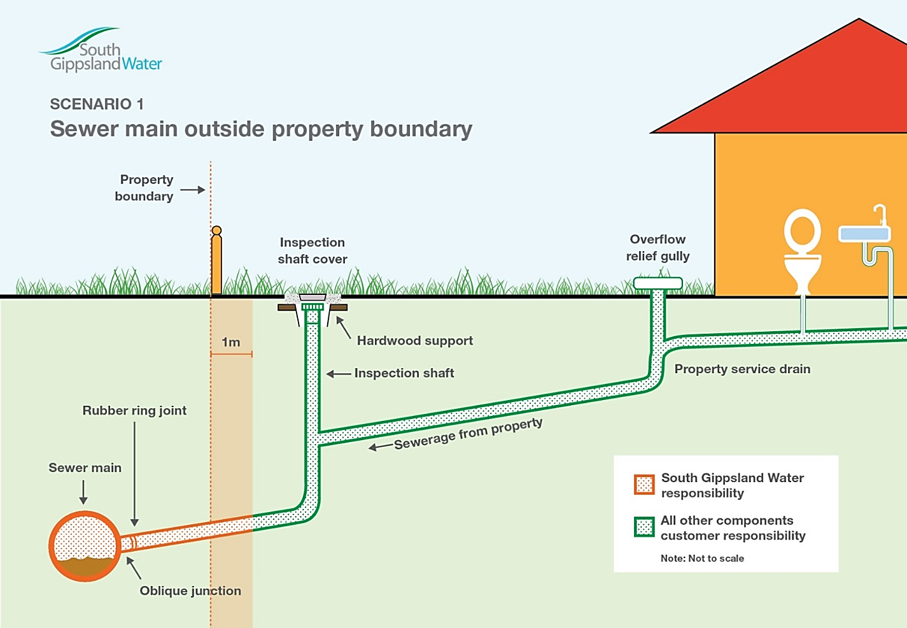
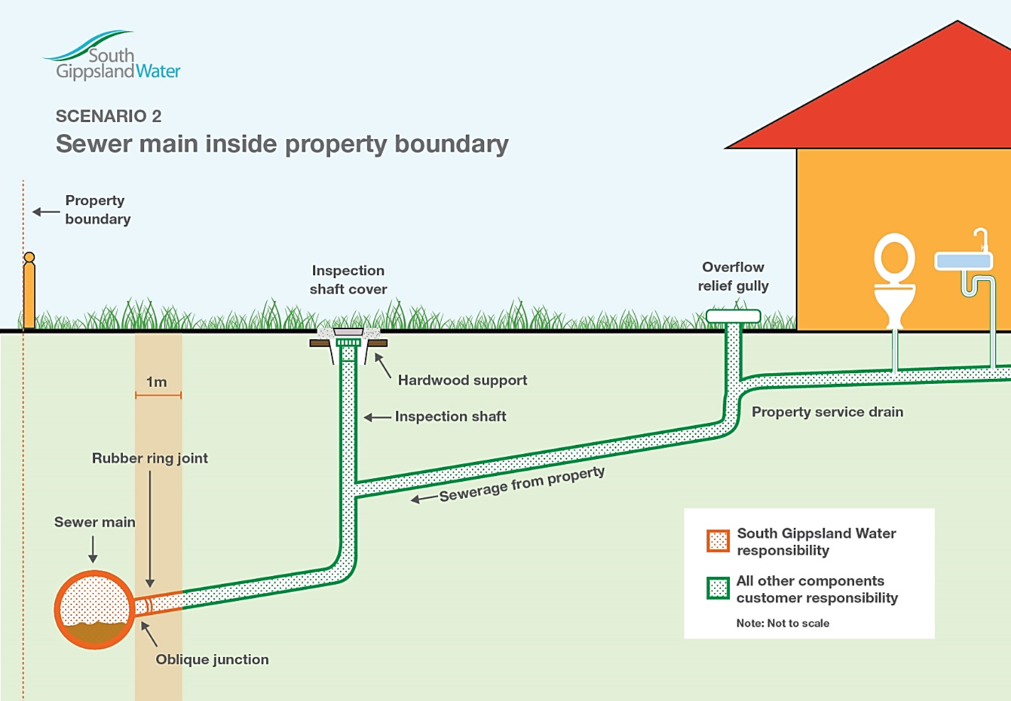

Reimbursement of plumbing expenses form

  - Customer Details

Contact Name: Account #:

Job address: Phone:

Email: SGW WO #:
  - Plumber Details
Business name: Business Address:

Contact person: ABN:

Phone number: Email:

  - Job Details
Date of job: Invoice #:

Invoice cost:
Was a property plan obtained? (Please circle) YES / NO

Where was blockage identified?
Description of works
and blockage cause:

  - Payment Details
Claim amount:

BSB: Account #:

Bank Account name:

Signature: Invoice has been attached YES / NO

Date:

