WATER SECURITY OUTLOOK
JULY 2026
Water Supply Information
Water resources held by South Gippsland Water for the Meeniyan Water Supply System are shown below. Only 27% of the available annual entitlement has been used from the river in the past year (July 2025 to June 2026). This entitlement is a legal right to access water, subject to availability.
Water Component | Maximum Annual  Entitlement | Annual Volume Extracted 2025-26
Tarwin River at Meeniyan | 200 ML | 54 ML

Water Consumption
Monthly water consumption for the Meeniyan Water Supply System in the past year has remained largely consistent overall with the average demand over the last five years. Water consumption is expected to remain close to the historical average for the remainder of 2026.

Meeniyan Water Supply System

Meeniyan is supplied from the Tarwin River.
After diversion from the river, water is stored in a raw water basin prior to treatment and storage in a water tower. This water tower helps South Gippsland Water to maintain supply during peak demand periods in the morning and evening.

South Gippsland Water
1300 851 636
www.sgwater.com.au
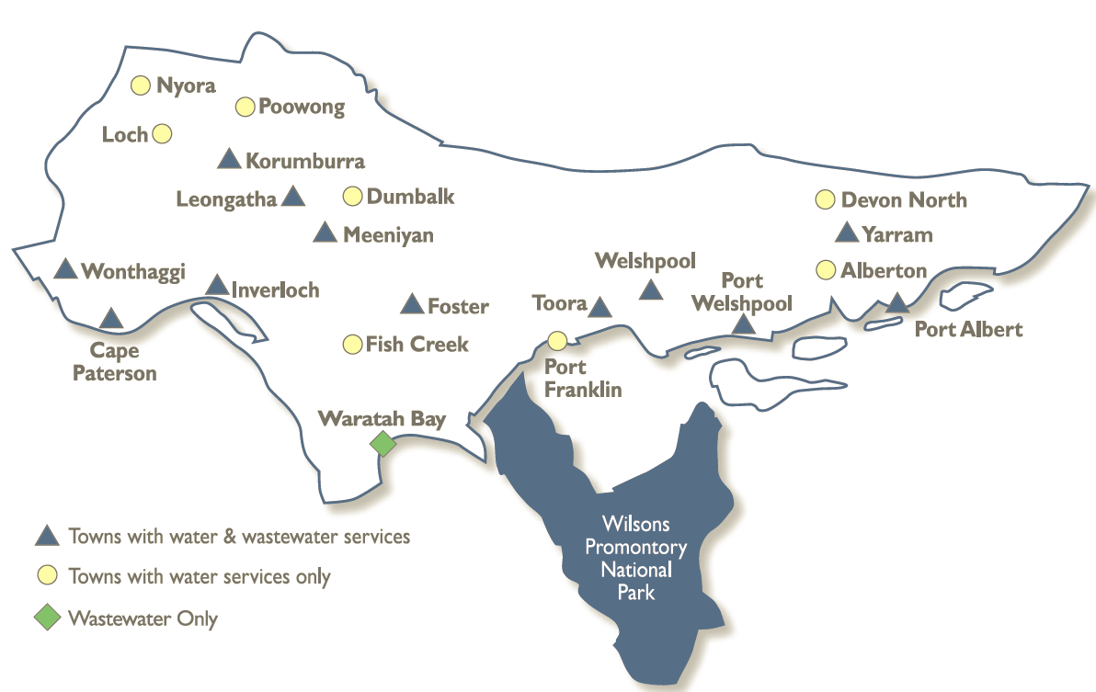
WATER SECURITY OUTLOOK
JULY 2026

Climate Conditions
Forecast climate conditions for the coming three months have considered the Bureau of Meteorology’s seasonal climate forecast for the region and local climate conditions in the year to date. In the year to date, spring rainfall was above average, followed by a drier than usual summer and autumn, and the Bureau’s climate outlook indicates drier than usual conditions over the next three months. Air temperature is forecast over the next three months to be warmer than usual for this time of year, and this trend is expected to continue beyond this period. After taking these factors into account, South Gippsland Water is forecasting on the basis of a dry climate scenario.
Chance of Exceeding Median Rainfall | Chance of Exceeding Median Maximum Temperature | This Year’s Rainfall | Likely Outlook Scenario
25-30% | Greater than 80% | Above average in spring, below average in summer and autumn | Dry

Further Information:
- The most recent records for the Tarwin River at Meeniyan show that it was flowing at an average of 415 ML/d during March. This is well above SGW’s restriction trigger of 5 ML/d
- Unregulated river flows are difficult to forecast. SGW has only forecast the next 3 months due to low forecast skill beyond 3 months.
- Units are in megalitres per day (ML/d), where 1 ML is equivalent to 1 million litres.

Streamflow Outlook
Streamflow in the Tarwin River is naturally highly variable. Following a wet November, streamflow has gradually declined below the streamflow average during autumn. Streamflow remains well above historically drier years, and this is expected to persist throughout winter and spring. Water restrictions have previously only been enacted during extreme drought. Whilst precisely forecasting streamflow conditions is difficult, streamflow for the outlook period is currently expected to remain well above historic dry-year streamflow conditions. River flows are expected to remain above the 5 ML/d trigger for restrictions.

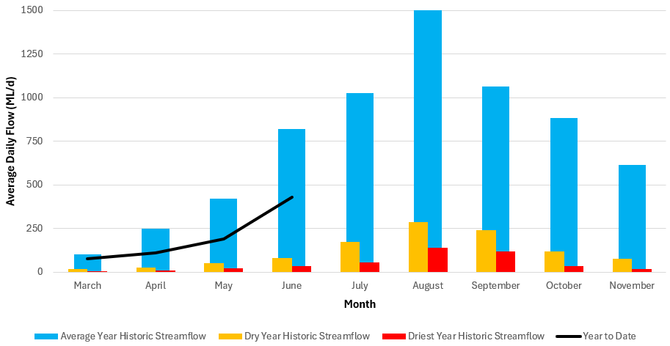

WATER SECURITY OUTLOOK
JULY 2026
South Gippsland Water
1300 851 636
www.sgwater.com.au

Urban Water Restrictions Outlook
Based on the recent streamflow record, the Bureau of Meteorology climate forecast and SGW’s daily streamflow forecast, no water restrictions are anticipated over the outlook period at the current time. South Gippsland Water’s Permanent Water Saving Rules applies to all customers over the outlook period.
Climate Scenario | Outlook
Climate Scenario | 1 July 2026 | 1 August 2026 | 1 September 2026
Wet | PWSR | PWSR | PWSR
Average | PWSR | PWSR | PWSR
Dry | PWSR | PWSR | PWSR
Worst on Record | PWSR | PWSR | PWSR
PWSR Permanent Water Saving Rules

Action Plan
A list of priority actions for this supply system prior to the next update of the Urban Water Strategy in 2027 is presented below. Further information on actions can be found in our 2022 Urban Water Strategy and our Price Submission 2023-2028 publication on our website. Victoria’s permanent water savings rules are always in place in South Gippsland, saving water on an ongoing basis. For additional tips about how to save water see our smart water advice.
Action Name | Timing
Water awareness and efficiency programs | Ongoing
Leak reduction | Ongoing
Reuse opportunities | Ongoing
Update water security outlook | Every November
Planning for long term options as per the Urban Water Strategy | 2022-2027

The information provided in this water security outlook is intended as a guide only. An update will be issued if conditions change during the outlook period.

South Gippsland Water
1300 851 636
www.sgwater.com.au
Blah

Water Consumption
Lance Creek Water Supply System monthly actual water consumption versus historical consumption

Table

Water Supply Information
Water resources held by South Gippsland Water for the Lance Creek Water Supply System

