WATER SECURITY OUTLOOK
JULY 2026
South Gippsland Water
1300 851 636
www.sgwater.com.au
Water Supply Information
Water resources held by South Gippsland Water for the Tarra River Water Supply System are shown below. Only 49% of the available annual entitlement has been used from the Tarra River in the past year (July 2025 to June 2026). 20 ML of groundwater was pumped over the same period. This entitlement is a legal right to access water, subject to availability.
Water Component | Maximum Annual  Entitlement | Annual Volume Extracted 2025-26
Tarra River | 853 ML | 420 ML
Groundwater Bore | 214.2 ML | 20 ML

Water Consumption
Monthly water consumption for the Tarra River Water Supply System in the past year was slightly lower than the past 5 year average demand overall. Water consumption is expected to remain close to the historical average for the remainder of 2026.

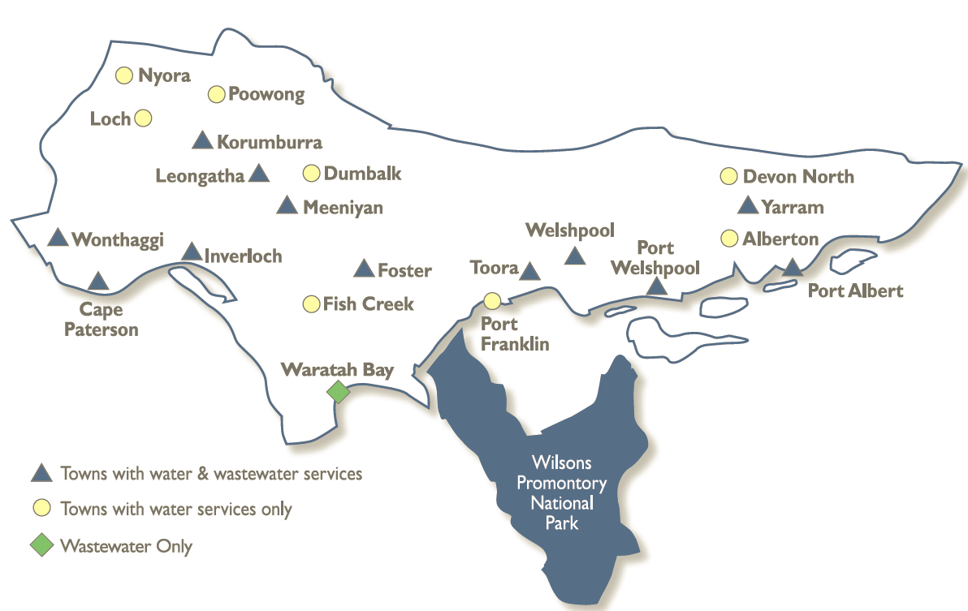
The Tarra River Water Supply System supplies water to the townships of:
- Yarram;
- Alberton;
- Port Albert; and
- Surrounding rural communities.
Primary supply is from a diversion weir on the Tarra River, with backup supply from a groundwater bore. Both sources of water are transferred to a storage basin, with a capacity of 30 ML. This storage allows water supply to be maintained during short periods of low river flow during drought.
Tarra River Water Supply System

WATER SECURITY OUTLOOK
JULY 2026

Climate Conditions
Forecast climate conditions for the coming three months have considered the Bureau of Meteorology’s seasonal climate forecast for the region and local climate conditions in the year to date. In the past year, rainfall was generally slightly below average, but the Bureau’s climate outlook indicates drier than usual conditions over the next three months. Air temperature is forecast over the next three months to be warmer than usual for this time of year, and this trend is expected to continue beyond this period. After taking these factors into account, South Gippsland Water is forecasting on the basis of a dry climate scenario.
Chance of Exceeding Median Rainfall | Chance of Exceeding Median Maximum Temperature | This Year’s Spring/Summer Rainfall | Likely Outlook Scenario
25-30% | Greater than 80% | Below Average | Dry

Further Information:
- The most recent records for the Tarra River upstream of the diversion weir show that it was flowing at an average of 26 ML/d during June. This is well above the 5 ML/d flow threshold to activate groundwater pumping, which is used to deal with water shortages.
- The Yarram storage basin was 100% full at the end of June.
- Unregulated river flows are difficult to forecast. SGW has only forecast the next 3 months due to low forecast skill beyond 3 months.
- Units are in megalitres per day (ML/d), where 1 ML is equivalent to 1 million litres.

Streamflow Outlook
Streamflow in the Tarra River is naturally highly variable. Streamflows fell below the historical average for the first time in 2026 during June. Whilst precisely forecasting streamflow conditions is difficult, streamflow for the outlook period is currently expected to remain sufficient and well above historic dry-year streamflow conditions.
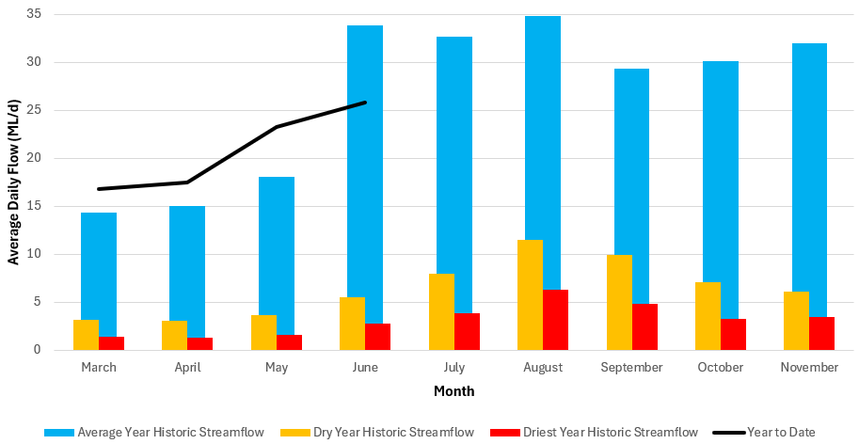

Urban Water Restrictions Outlook
Based on the streamflow outlook, the demands for water in the year to date, and the Bureau of Meteorology climate forecast, no water restrictions are anticipated for the remainder of the year at the current time. It is expected that the groundwater bore entitlement use will remain low for the remainder of 2026. South Gippsland Water’s Permanent Water Saving Rules applies to all customers over the outlook period.
Climate Scenario | Outlook
Climate Scenario | 1 July 2026 | 1 August 2026 | 1 September 2026
Wet | PWSR | PWSR | PWSR
Average | PWSR | PWSR | PWSR
Dry | PWSR | PWSR | PWSR
Worst on Record | PWSR | PWSR | PWSR
PWSR Permanent Water Saving Rules

South Gippsland Water
1300 851 636
www.sgwater.com.au

WATER SECURITY OUTLOOK
JULY 2026

Action Plan
A list of priority actions for this supply system prior to the next update of the Urban Water Strategy in 2027 is presented below. Further information on actions can be found in our 2022 Urban Water Strategy and our Price Submission 2023-2028 publication on our website. Victoria’s permanent water savings rules are always in place in South Gippsland, saving water on an ongoing basis. For additional tips about how to save water see our smart water advice.
Action Name | Timing
Water awareness and efficiency programs | Ongoing
Leak reduction | Ongoing
Reuse opportunities | Ongoing
Update water security outlook | Every November
Planning for long term options as per the Urban Water Strategy | 2022-2027

The information provided in this water security outlook is intended as a guide only. An update will be issued if conditions change during the outlook period.

South Gippsland Water
1300 851 636
www.sgwater.com.au
Blah

Water Consumption
Lance Creek Water Supply System monthly actual water consumption versus historical consumption

Table

Water Supply Information
Water resources held by South Gippsland Water for the Lance Creek Water Supply System

